Cloudera Data Science Workbench - Hands-on Workshop

## Exercise Manual



May 31st, 2018 Created by Jordan Volz

Version 2 Systems Engineer @ Cloudera

## Exercise 1: Access & Team Management

Now that we have had an overview of CDSW, let’s get our hands dirty. The first thing we’ll need to do is log into the system. You should have received a login slip from the instructor. Navigate to the following URL in your browser and login with your user name and password:

<http://www.cdsw.jvolz-cloudera.com>

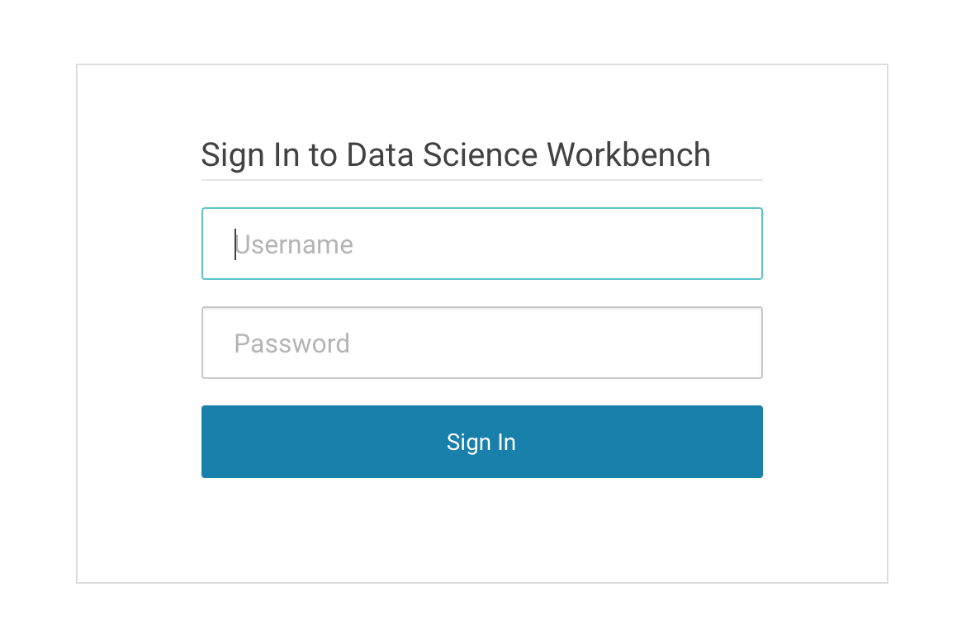

Once you are logged in, we can get started. Our CDH cluster is completely secured with Kerberos, so we’ll need to specify in our account profile how we can authenticate to the main CDH cluster. This allows us to do things like run Spark jobs, connect to data in HDFS, etc.

To do this, click on **Settings** > **Hadoop Authentication**, and then enter the **principal** and **credentials** that are printed on your slip. Click Authenticate and you should get a confirmation that it was successful. Now you’re ready to work with the cluster!

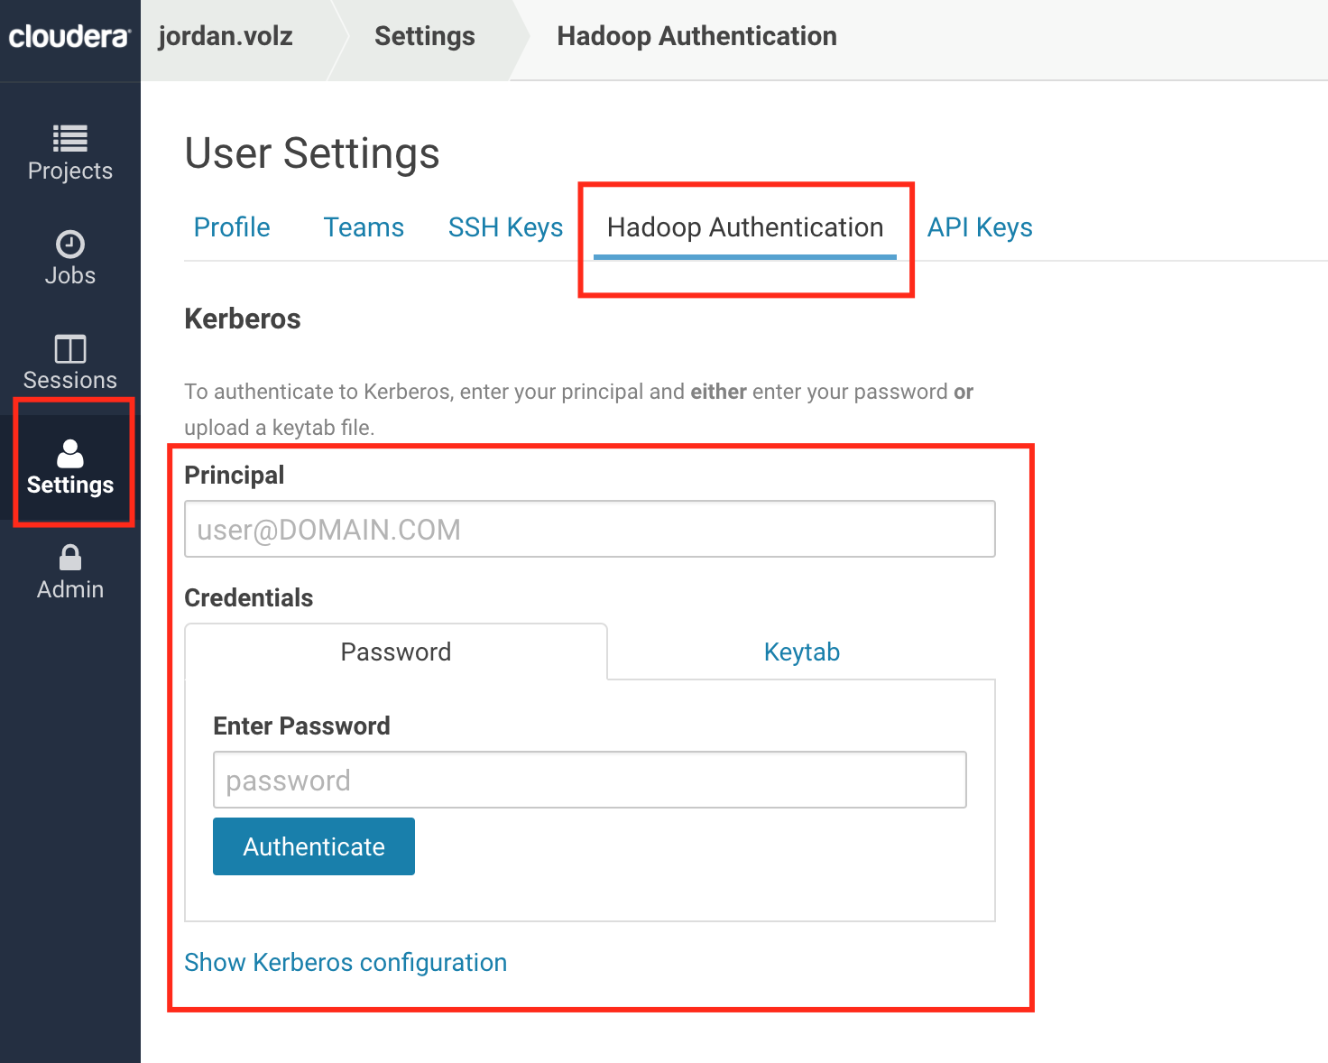

Before we start working with data and writing code, let’s orient ourselves in the system. Click on **Projects** in the vertical menu on the left side of the page, which takes you back to your dashboard. This shows you a list of your projects in the system, filtered by your current context (we’ll discuss this in a minute). You can click on any project to start creating and running code. The menu on the left has links to switch between different parts of the application, such as **Projects**, **Jobs**, **Sessions**, and **User Settings**. The top of the page shows a breadcrumb trail that allows you to navigate through the system. Below the breadcrumb trail and above the project list is a panel displaying the system resources. This corresponds to the resources available and being used in the CDSW cluster (not the main CDH cluster). You’ll see 4 boxes – sessions running, jobs running, vCPU, and Memory, and a 5th one – GPU – if you have a GPU-enabled node in your CDSW cluster (in this lab we did not add a GPU-enabled node, so you will only see 4 boxes). The blue bar shows how many resources are being used in the system, whereas the green bar shows how many you are taking up. You can hover over a bar to display their values, but by default it will always display how many resources you are currently using.

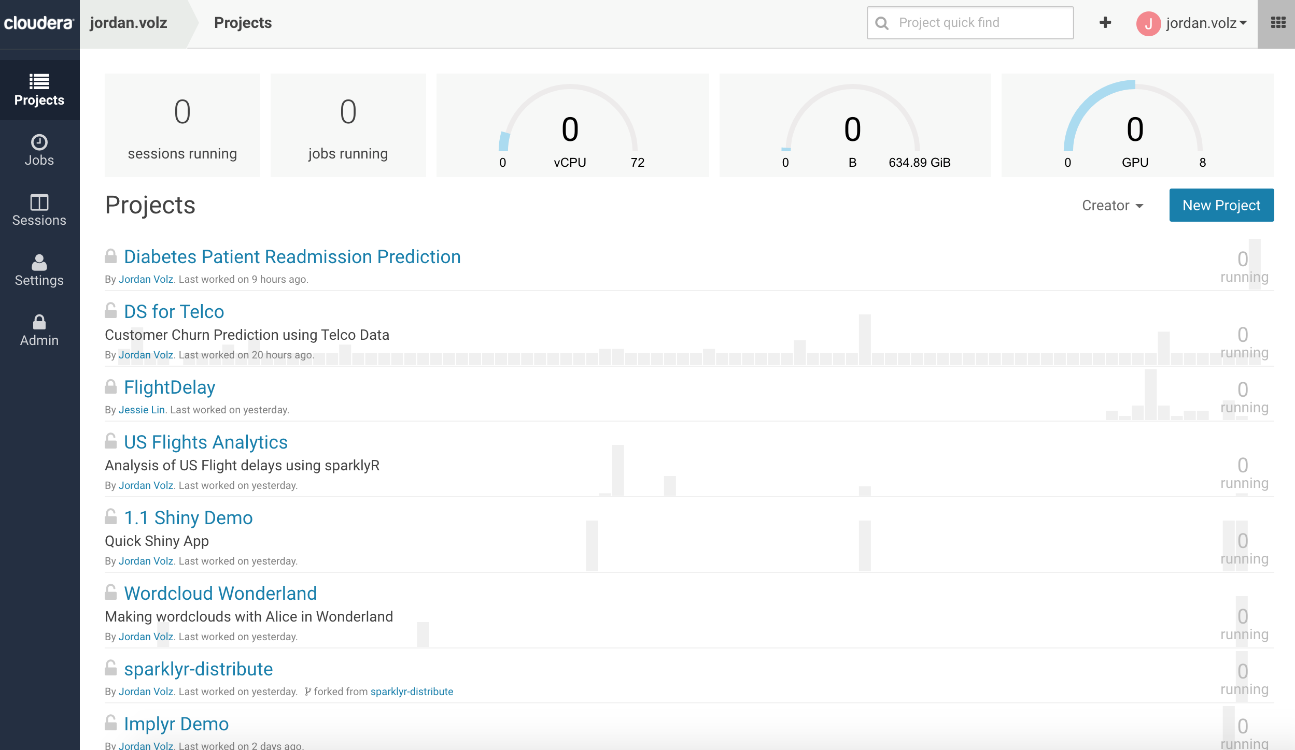

**Projects** are the main tool to organize and run code in CDSW. This is where we will be spending most of our time. Before we dive into that, however, we need to be able to specify who we want to collaborate with. This is mainly accomplished in CDSW via **Teams**. Let’s see how to create a new Team.

At the top of the page you’ll see the name of the user you logged in as, as well as a big **+** to the left of it. Click the **+** and select **Create Team**.

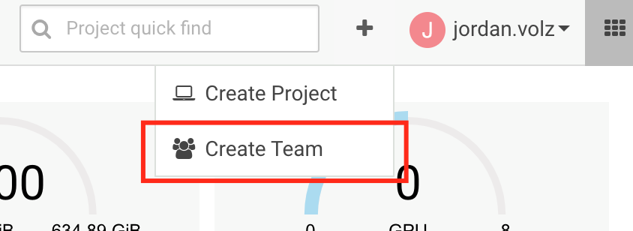

Now enter the name of your team. Give it a unique name that will allow you to distinguish it from other people’s teams in the system, like “<first_name>’s Avengers” or “<initials> Justice League”. Click **Create Team**.

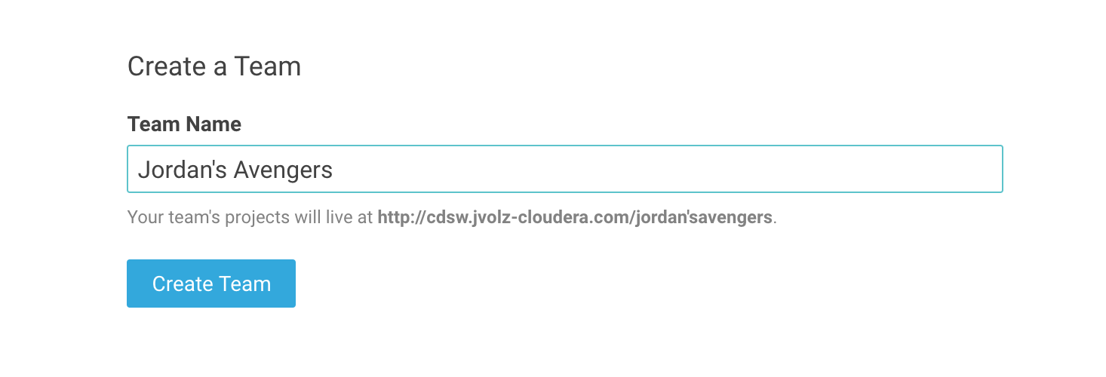

The next screen allows you to add people to collaborate with. You were really impressed by the instructor’s knowledge during his presentation at the beginning of the day, and you may want him to help you out with some of the upcoming challenges. Type “Jordan” into the top box and then select the third option that pops up in the autocomplete: “Jordan Volz”. After a second you should see Jordan Volz added to your team.

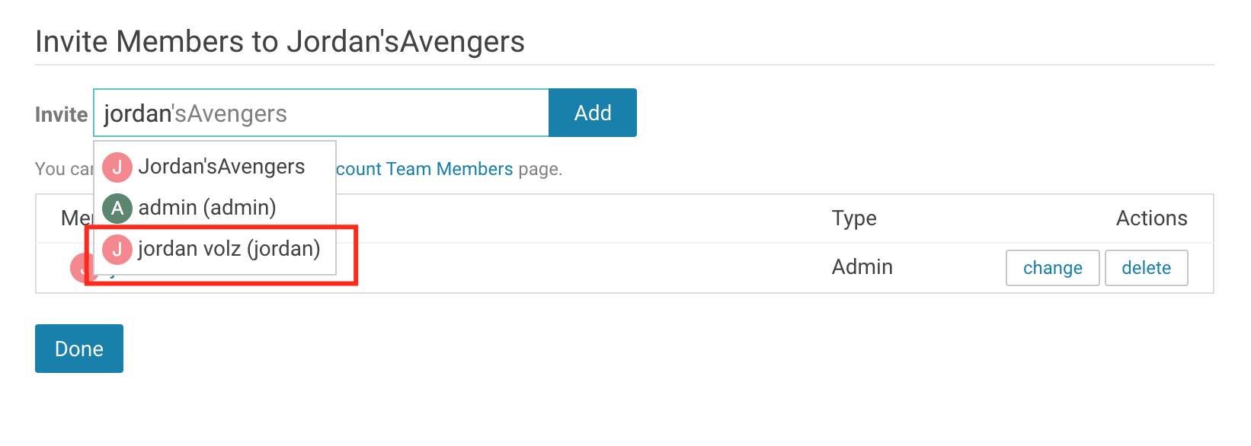

In the row with Jordan Volz’s name, click **Change.** This shows how you can modify what roles users have in your team. Some may be *viewers*, meaning they can’t create projects but can be added to existing ones, some may be *contributors*, meaning they can create projects and be added to existing ones, and some may be *admins*, which means they have full access to all projects in the team. Let’s leave Jordan’s role at contributor for now. This is also where you can edit or remove existing team members’ roles in the future. When you’re finished, click **Done**.

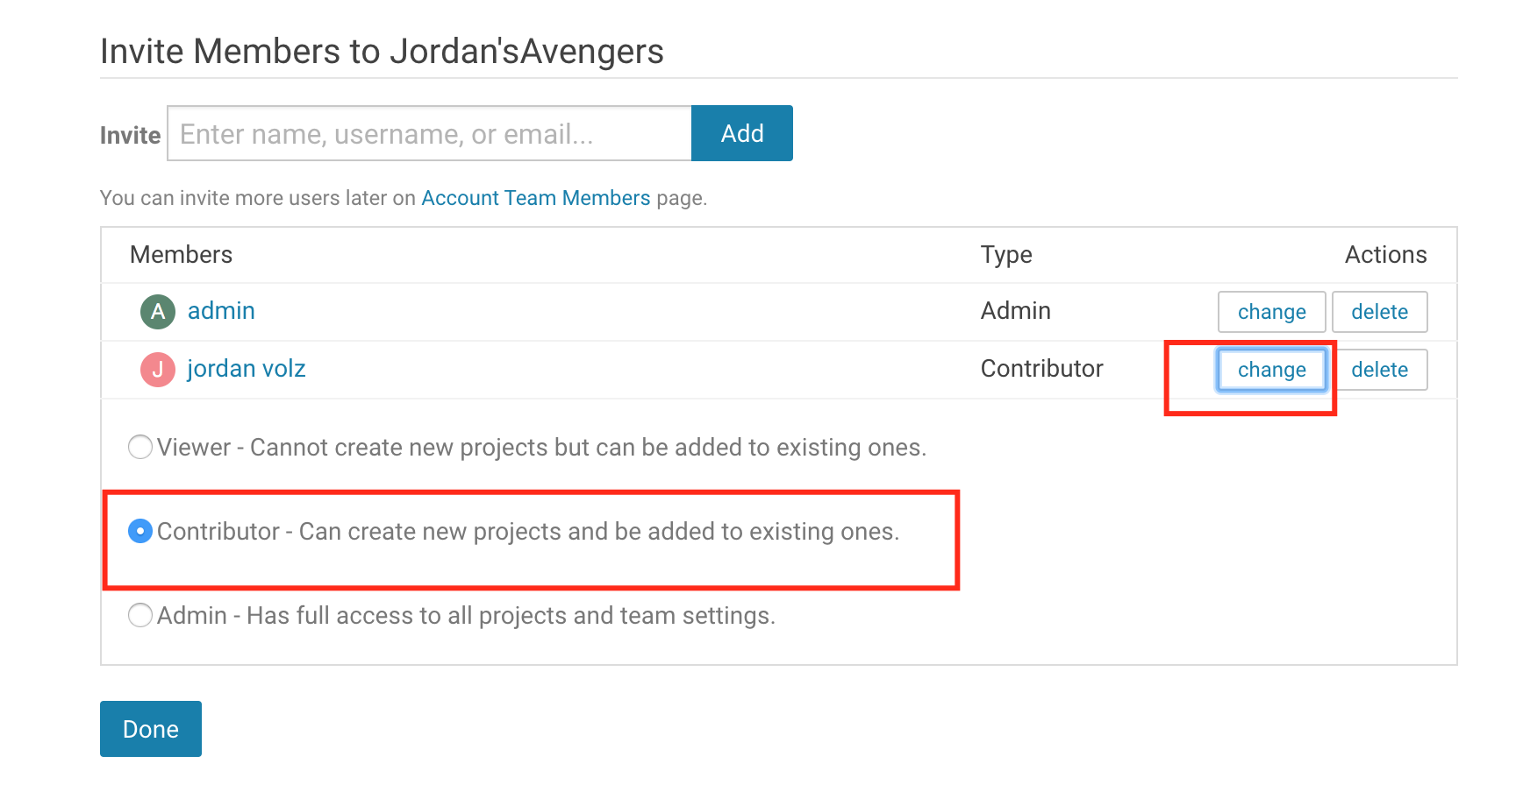

Before we start working with projects, go back to the dashboard by clicking on **Projects**. In the top right corner, you should notice your context has switched to the team you just created. If you click the drop down, you’ll see you can switch back to your personal user account. We don’t have any projects yet, but this is how you can switch between different teams in the system and your list of projects will be displayed based that team.

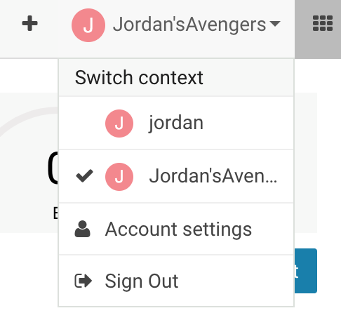

## Exercise 2: Creating a New Project from Scratch

Now we are ready to create a project! *Projects* is where you will write and execute code in the system. This is where you will likely spend most of your time when using CDSW. Let’s create a new project. Make sure you are on your dashboard, then you can either click the arrow in the top toolbar and click **Create Project**, or click the blue **New Project** button below your resource toolbar.

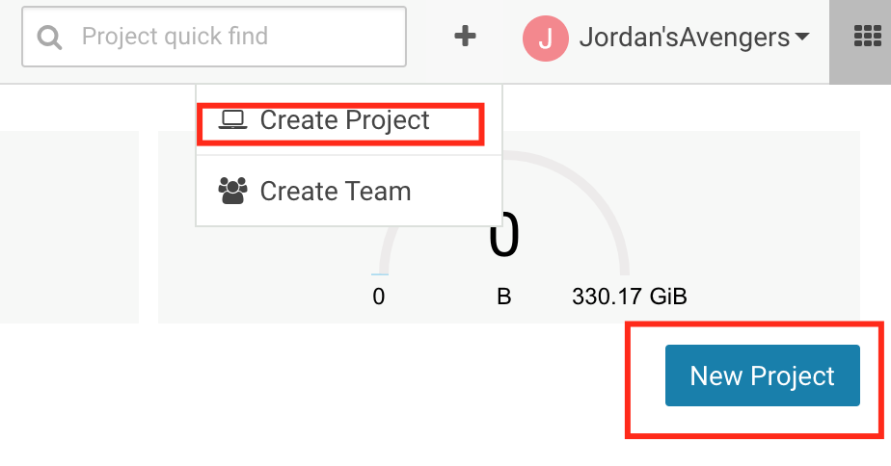

You should see a short form to fill out for your new project. First, select which account to place this project in. Let’s select **the team we created in Exercise 1**. Now, give your project a name, like **“Exercise 2”**. Next, select who will be able to access the project. For this example, let’s select **Team**, which will make the project available to everyone on our team, with the roles defined in the team. It’s also possible to make a project private, or public. We can always change the visibility later. Lastly, we can optionally provide some information on the types of files we want to include in the project. Select Template > Python. CDSW comes with a few templates which are mainly for demonstrative purposes, and system admins can also upload custom templates into the system. We can optionally create a blank project, upload local files from our laptop, or clone an existing github project. We’ll explore some of these other options in future exercises. When finished, click **Create Project**.

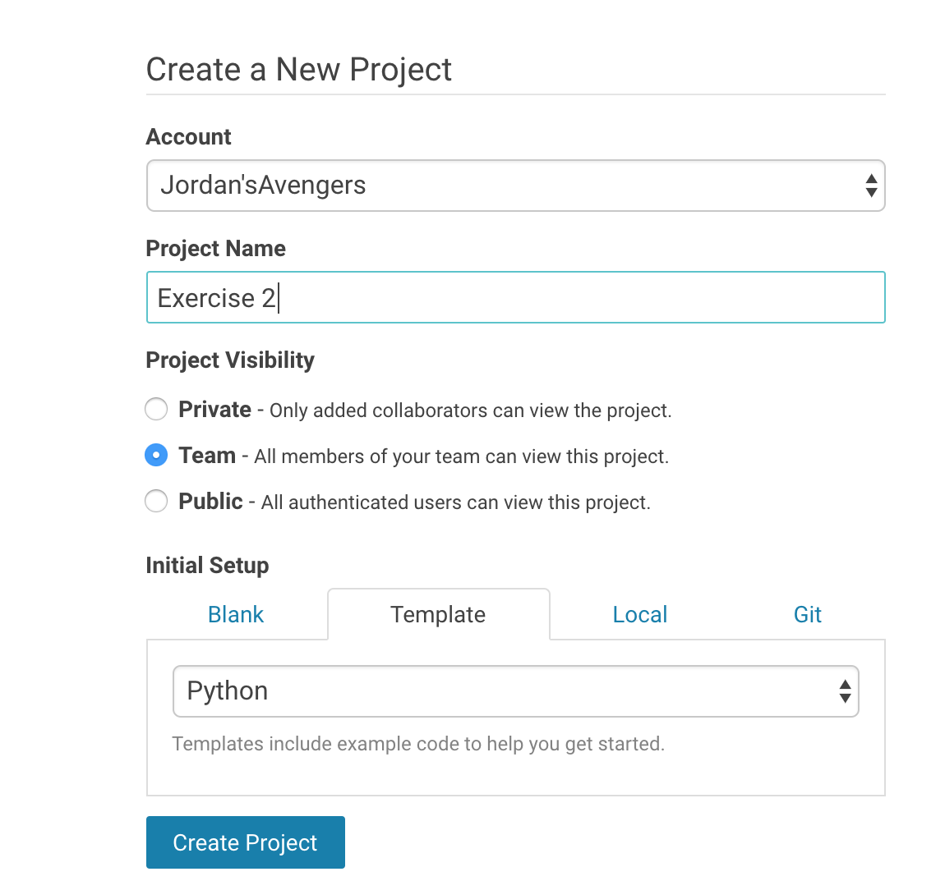

After creating a project, you’ll be taken to the project dashboard. This provides a high-level overview of the project. At a glance, you’ll be able to see which **Jobs** have been configured for the project, a list of **Files** in the project (you can also upload and download files from here), and any description provided in the form of a **README.md** file. Notice that since we selected a python template, we already have some pre-populated files in this project. You can also modify who has access to the project by clicking **Team** on the left menu and adding project collaborators. Like the team settings, projects have 3 levels of access: *viewer*, who only has read-access, *contributor*, who can modify and execute project, and *admin*, who has full access to the system. You’ll spend most of the time in your project working in the workbench, so click the blue **Open Workbench** button at the top of the page.

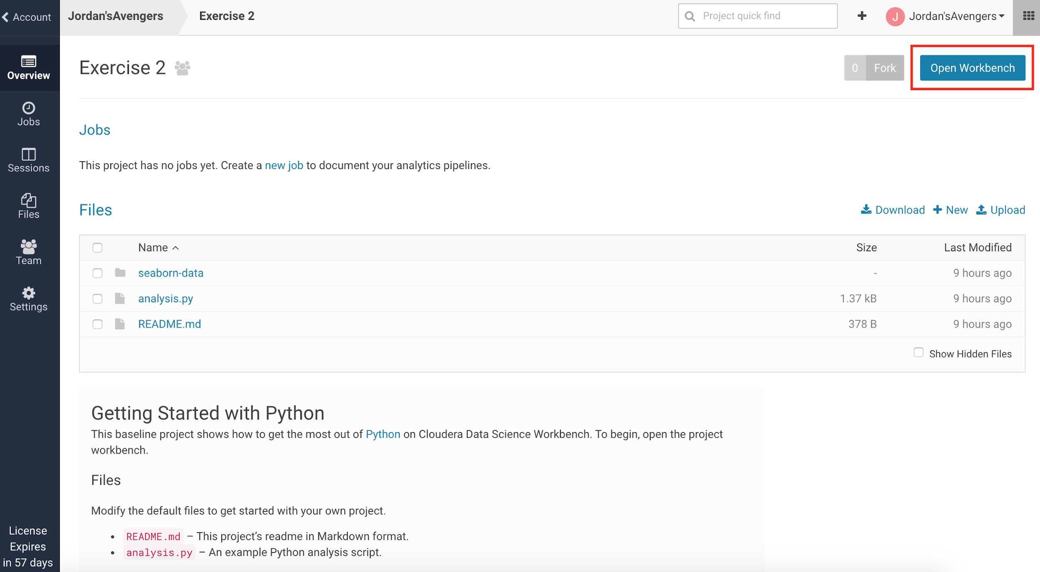

The workbench is broken into three panels. On the left is the list of *Files*, the middle panel is your *Editor*, and the right panel is your interactive *Session*. By selecting a file in the file list, the editor will display its content. Try this by clicking on **analysis.py** to display its contents. You’ll notice the file loads up in the editor, and you can modify or enter code in here to modify your *script*. For now, we don’t need to modify anything, so let’s just run our code.

To do so, we’ll need to create an interactive session. On the right, CDSW is asking us to specify which type of session we want (Python 2, Python 3, Scala, or R) and the resources we need for those sessions (Note: if using gpu-enabled nodes, you can also request GPU resources here as well). Both items are configurable by an admin (we’ll look at this a little later): you can modify the base images CDSW provides and create larger instance sizes if needed. Select **Python 2**, **1 vCPU/2 GB MEM**, and click **Launch Session**.

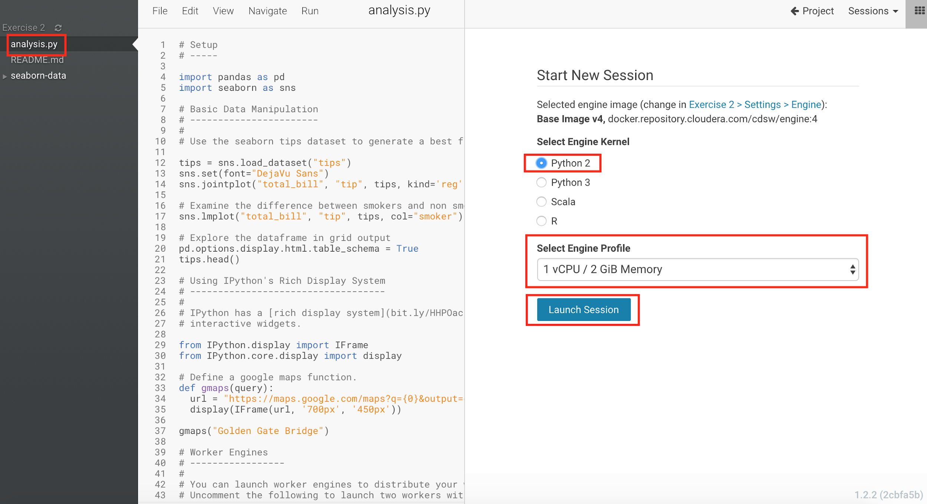

On the back end, CDSW provisions out a Docker container from which to run all your code. This is isolated from other users in the system, so you won’t have to worry about dependency conflicts, resource contention, etc. After launching the session, you should see a message about the container creating, and then the session starting. This should only take a few seconds for common engine types. After that, the console will have a green bar at the bottom, which means it is ready to use. Let’s test it out by typing the following and hitting enter:

print "Hello World!"

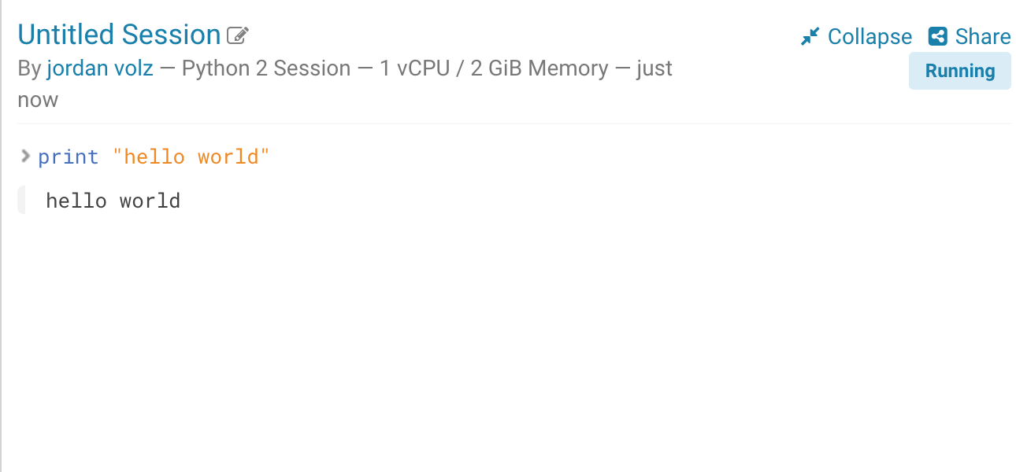

CDSW executes your code in the session, and you’ll see the results displayed immediately. Our base engine is based off a Jupyter kernel, so users familiar with working in Jupyter Notebooks should find the experience very similar. I.E. many [magics are supported](https://www.chttps//www.cloudera.com/documentation/data-science-workbench/latest/loudera.com/documentation/data-science-workbench/latest/topics/cdsw_jupyter.htmlhttps://www.cloudera.com/documentation/data-science-workbench/latest/topics/cdsw_jupy), etc. This session provides a typical python experience to users, so you can freely run local python processes from here (later we’ll discuss connecting to the cluster to run distributed spark jobs, etc). For now, let’s just run our existing code in the session. To do that, you can either click the **Play** button on the top of the editor, or click **Run** and select **Run All**.

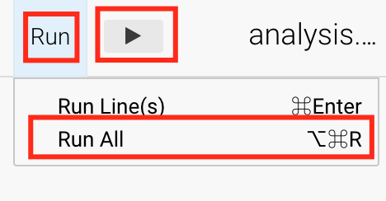

Your code should run in just a few seconds. Notice that our code contains some visualizations and also demonstrates working with popular libraries like *pandas* and *seaborn*. The CDSW base engine comes with many libraries pre-installed, including these, and users also have the ability to install additional dependencies as needed (more on this later). The goal here is to give Python users a familiar experience while connecting them to big data resources.

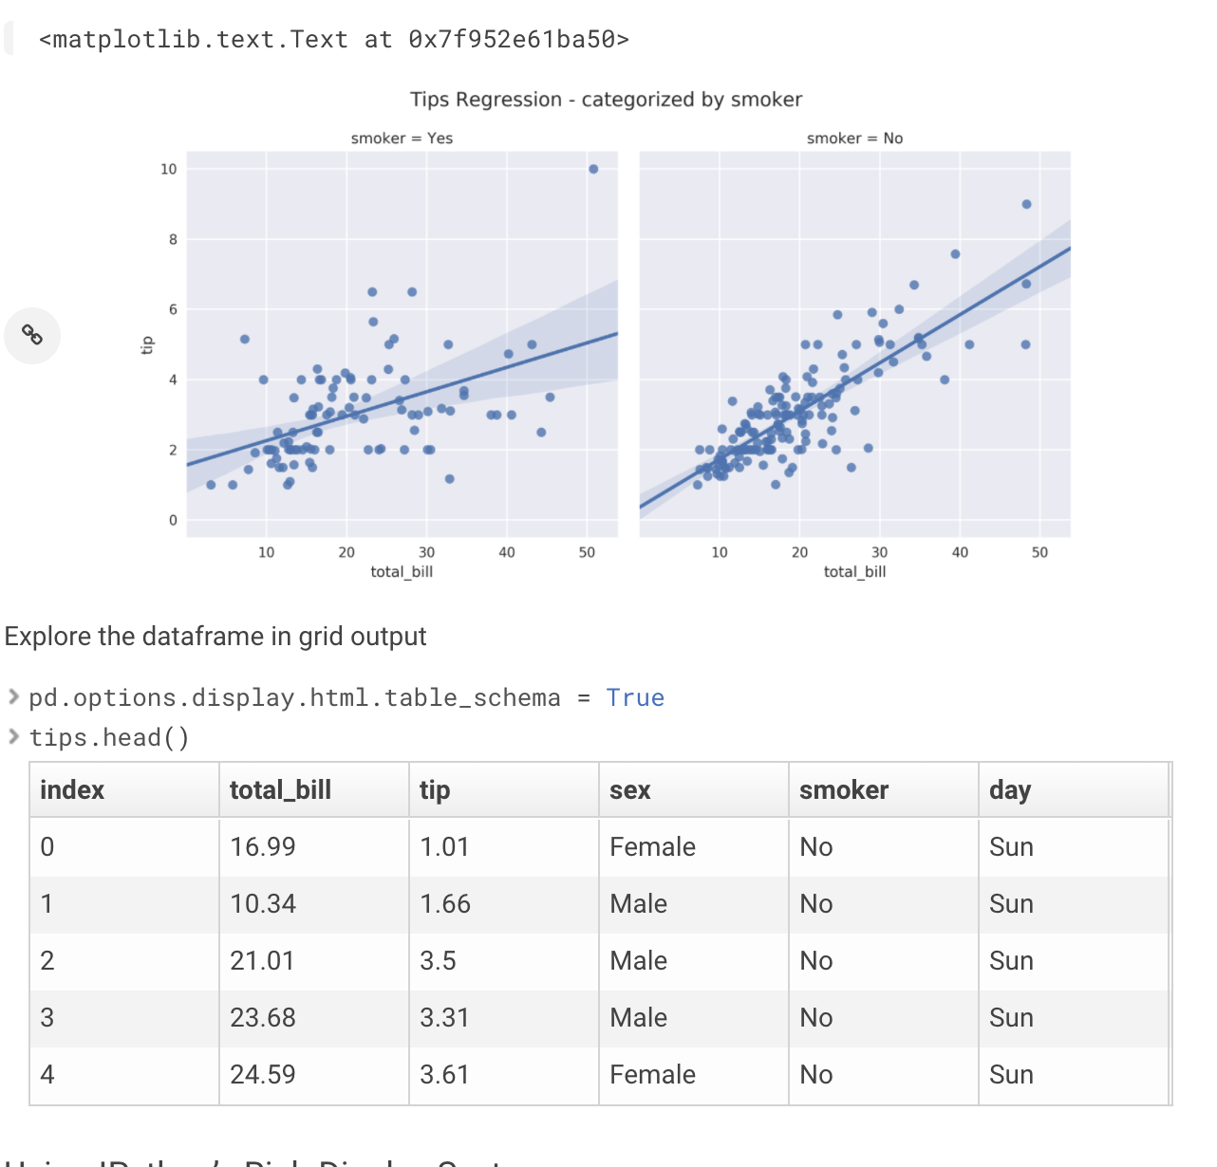

We are finished with this exercise, let’s just free up our resources as a last step. To do this, click the Stop button on the top of the session. This destroys the docker container and frees up the system resources. Don’t worry, your code is still saved in your project and we also keep a history of all your past sessions, should you wish to revisit them.

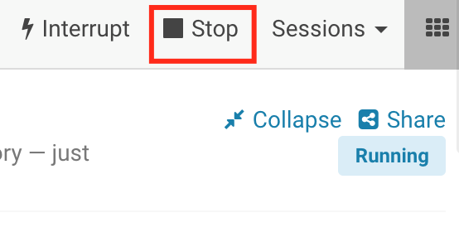

## Exercise 3: Creating a New Project from Github

In this exercise, we’ll show how you can setup a setup a project from an existing Github repository. We’ll also look at a project that uses Spark to interact with the cluster. Navigate back to the main dashboard. If you’re still in the workbench for Exercise 2, click **Project** at the top of the page, and then Account.

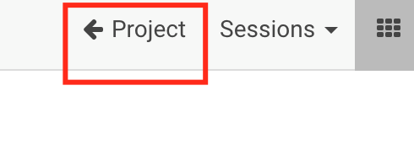

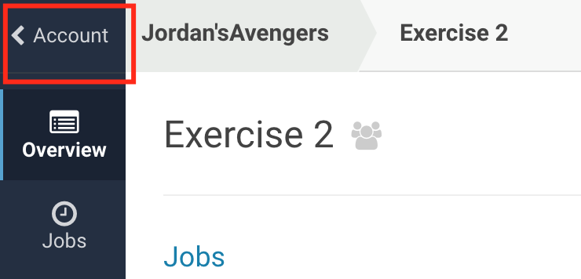

We need to create a new project so Click **Create Project** like we did in Exercise 2. Put this project in your **Personal Account** instead of your team account, Give the project a name like **“Exercise 3”**,make it a **Private** project and initialize the project with **Git** by using the following url:

<https://github.com/jordanvolz/BasketballStatsCDSW>

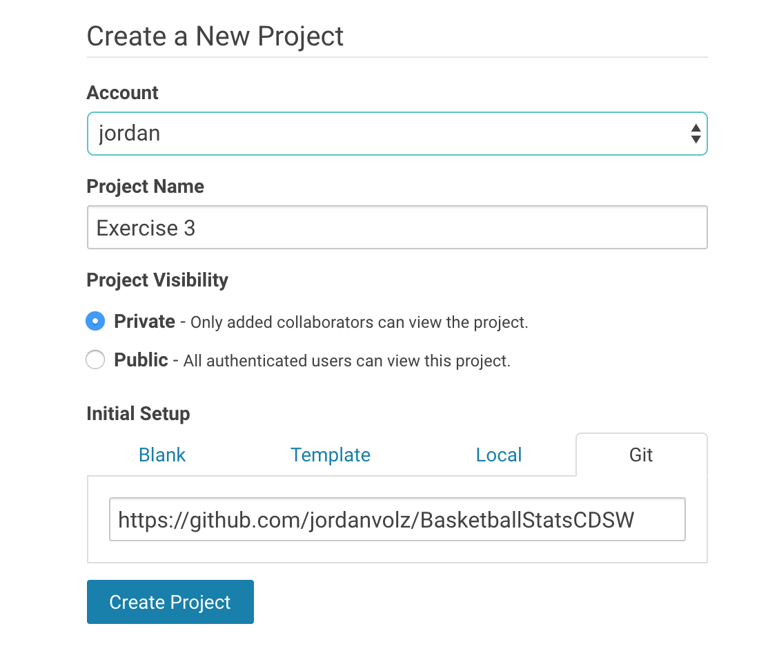

Click **Create Project**. This will clone the repository and create a new CDSW project with the contents of that repo. You should see a page that looks something like the following image. This project already has several scripts around data processing, data analytics, and machine learning that we can use in CDSW.

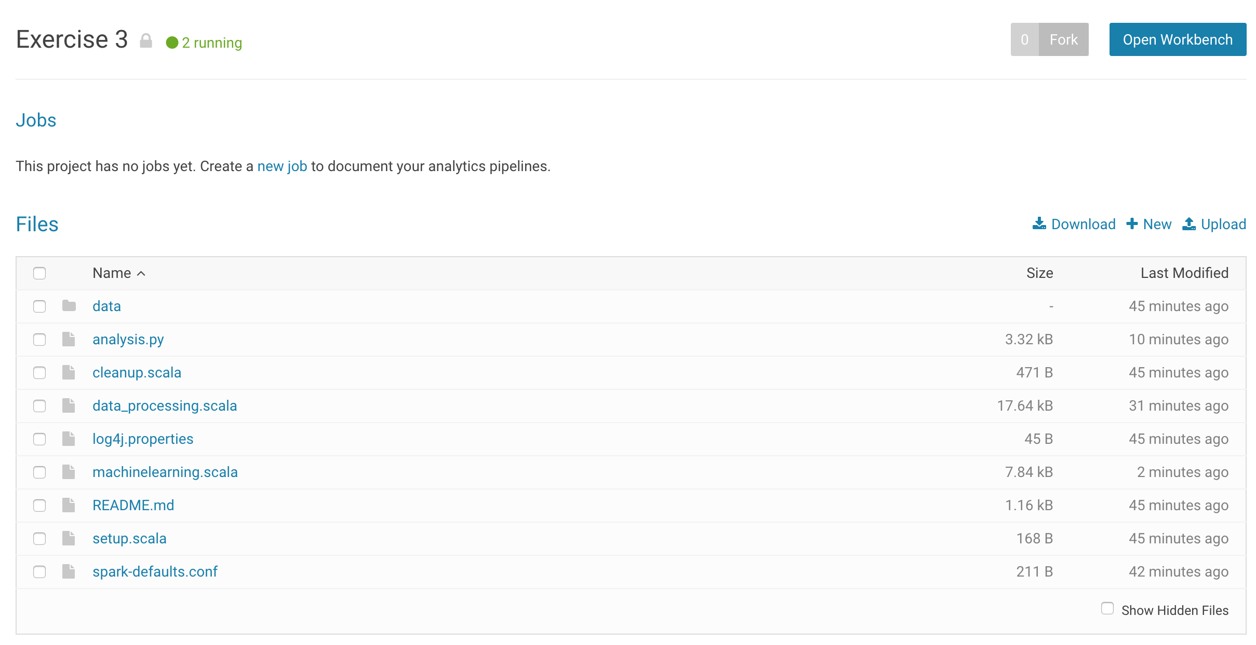

Before we get started in the workbench, let’s add a collaborator to the project. We didn’t put this project in a team, but we can still add users to the project who we want to collaborate with. Click on **Team** on the left and then search for the user **jordan.** Add him to the project, and you change his permission to Administrator.

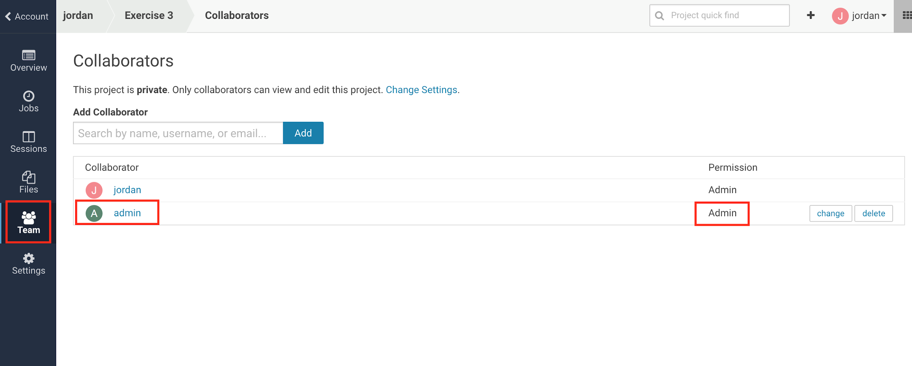

We can always ad-hoc add users to our personal projects. Your personal projects by default will contain you as the sole collaborator, so if you expect to be working with other people, it’s a best practice to use Teams to reduce the administrative steps at project creation.

Now let’s look at the project. Navigate back to the project dashboard by clicking **Overview** and click **Open Workbench**. If you inspect the project’s REAMDE.md, you’ll notice that the author has provided some steps for using this project. The first step is running a setup script that will place data into HDFS so that we can access it with Spark. We have already copied this data into HDFS, ***so you do not need to run setup.sh***. Instead, open a session that uses the **Scala** kernel with **1 CPU/2GB RAM**. It should take the system about 15 seconds to provision out your Scala image. Scala takes a little longer to spin up because our kernel for Scala establishes a spark connection automatically, which takes a few seconds to set up.

Once your session is ready, click on data_processing.scala to load the script into the editor. This script is almost ready to run as is. The one modification we will make is to replace “<Your User Name>” in the first name with the name of your user. For example, my system user is “jordan”, so my first line reads:

**val dbName = "jordan"**

The script will use this to create a Hive database of that name and create your tables underneath it. Once that edit has been made, you can run the entire script by clicking the **Play** button or selecting **Run All**. This script performs several rounds of data processing on the data we uploaded into HDFS and generates a few Hive tables. If you’re interested in the technical details of this script, feel free to speak to the instructor (there’s also a few blog posts linked in the README.md file).

The script will probably take ~1 min to run. When it is finished, let’s check that our tables were created correctly by running the following command:

spark.sql(s"Select name, zTot from $dbName.players where year=2017 limit 10 ").show

You should see a small table produced, like below (note: the actual entries will differ):

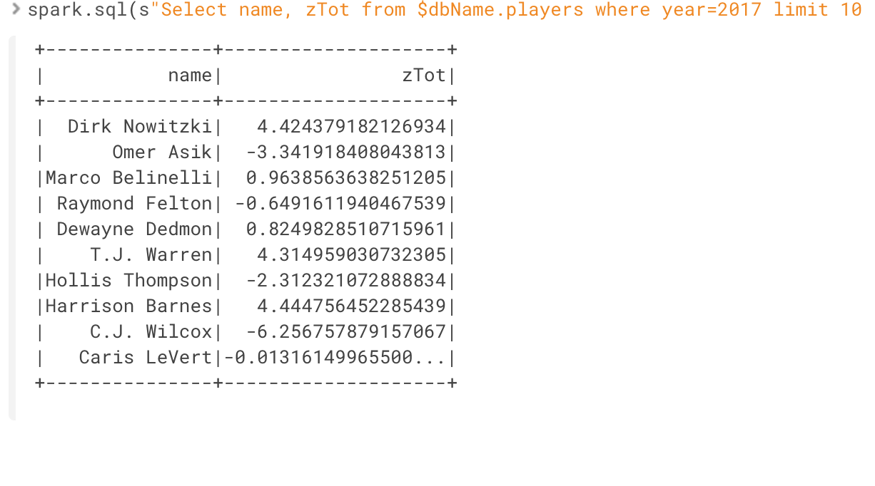

Now let’s look at the data analytics script. Click **analysis.py** to open the script in the editor. Again, change the first line in the script to replace “<Your User Name>” with the name of your system user.

**dbName = "jordan"**

We have a python script, but a scala session is running. Clearly, we can’t run python code in a Scala kernel. We’ll need to create a new Python2 session for our python code. CDSW lets you run multiple sessions at a time, so long as it has enough resources to satisfy the requests. Before we create a new session, let’s rename our current Scala session so that we can better identify it. At the top of the Session you should see the text “Untitled Session”. Click the **Pencil** next to it to edit the name and rename it something more descriptive, like **“<User Name>’s Scala Session”,** then click **Done**. This should replace the name of your session.

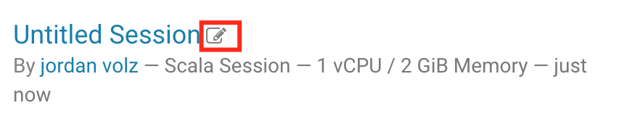



Now click the **Sessions** drop down menu at the top of the Sessions panel. You’ll see an entry for your current session, as well as the option to create a new session. Click “New Session” Then create a **Python 2** session with **1 CPU/2 GB RAM**.

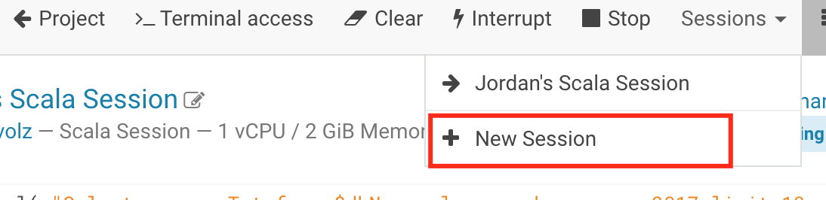

Once the session has started, you can optionally rename it like we did with the Scala Session. This will help organize your sessions if you start running many of them in the same project (something like **“<User Name>’s Python Session”** might be nice!). Now we can run the python script by selecting **Play** or **Run All**. When the script finishes, feel free to browse through it. What we do in this script is connect to the tables we created in the data_processing.scala script and run some visualizations on it using common Python methods. (Note: If you receive an error message about CDSW not having enough resources to create your session, try terminating your Scala session and then starting your Python2 session. If that doesn’t work, contact the Instructor, as it’s possible we’ve exhausted resources in the cluster and need to add some more nodes).

Notice that the Sessions dropdown menu allows you to switch between your running sessions in the project. This can be useful when multi-tasking – perhaps one session is running a lengthy model training or scoring session, you can easily go work on something else and return to the session later. This also allows you to run different scripts in different languages as needed.

We’re done with the workbench, but before we leave, let’s return to our starting point of having code on Github. We were able to pull code down from github, but what if we wanted to push it back to a repository? CDSW gives users shell access into their container, whey they can make use of common CLI tools like git. At the top of the session click **Terminal Access**. This will pop up a new window which contains a terminal. Git is already installed in the base image. Run a command like **“git status” or “git help”** in order to interact with git. This is where you would be able to commit changes back to a git repository, if you had suitable permissions. (Note that your CDSW user settings contains a SSH key that you can add to your github account to allow the tool to push code on your behalf. See the [documentation](https://www.cloudera.com/documentation/data-science-workbench/latest/topics/cdsw_using_git.html) for more details.)

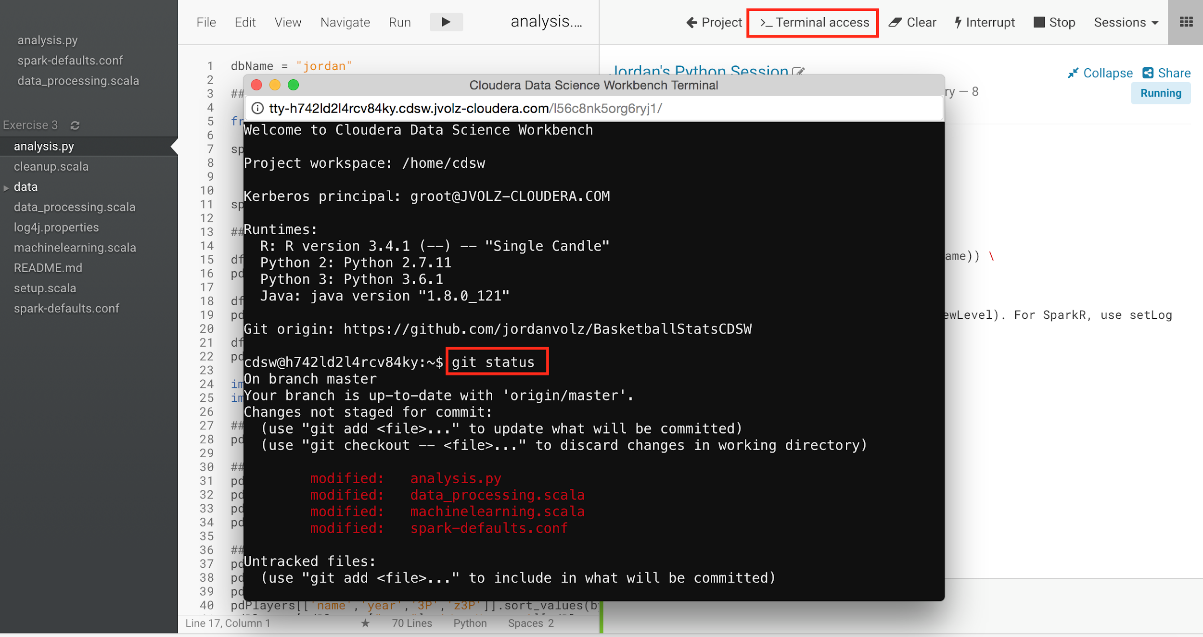

We’re done with this project, so let’s return to our dashboard (**Project** > **Accounts**). If you neglected to close your sessions, you’ll notice that the resource monitors now display how many resources you are using on the CDSW nodes, and your Exercise 3 project shows that 2 sessions are running:

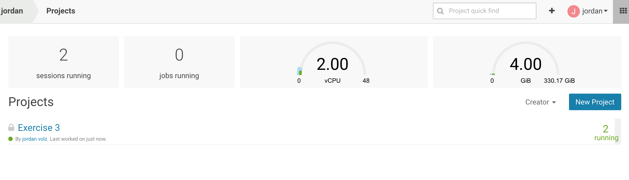

Also notice that since you are in our personal context, you only see the Exercise 3 project. You can switch to your team context via the dropdown in the top right to see that Exercise 2 is located in that team context.

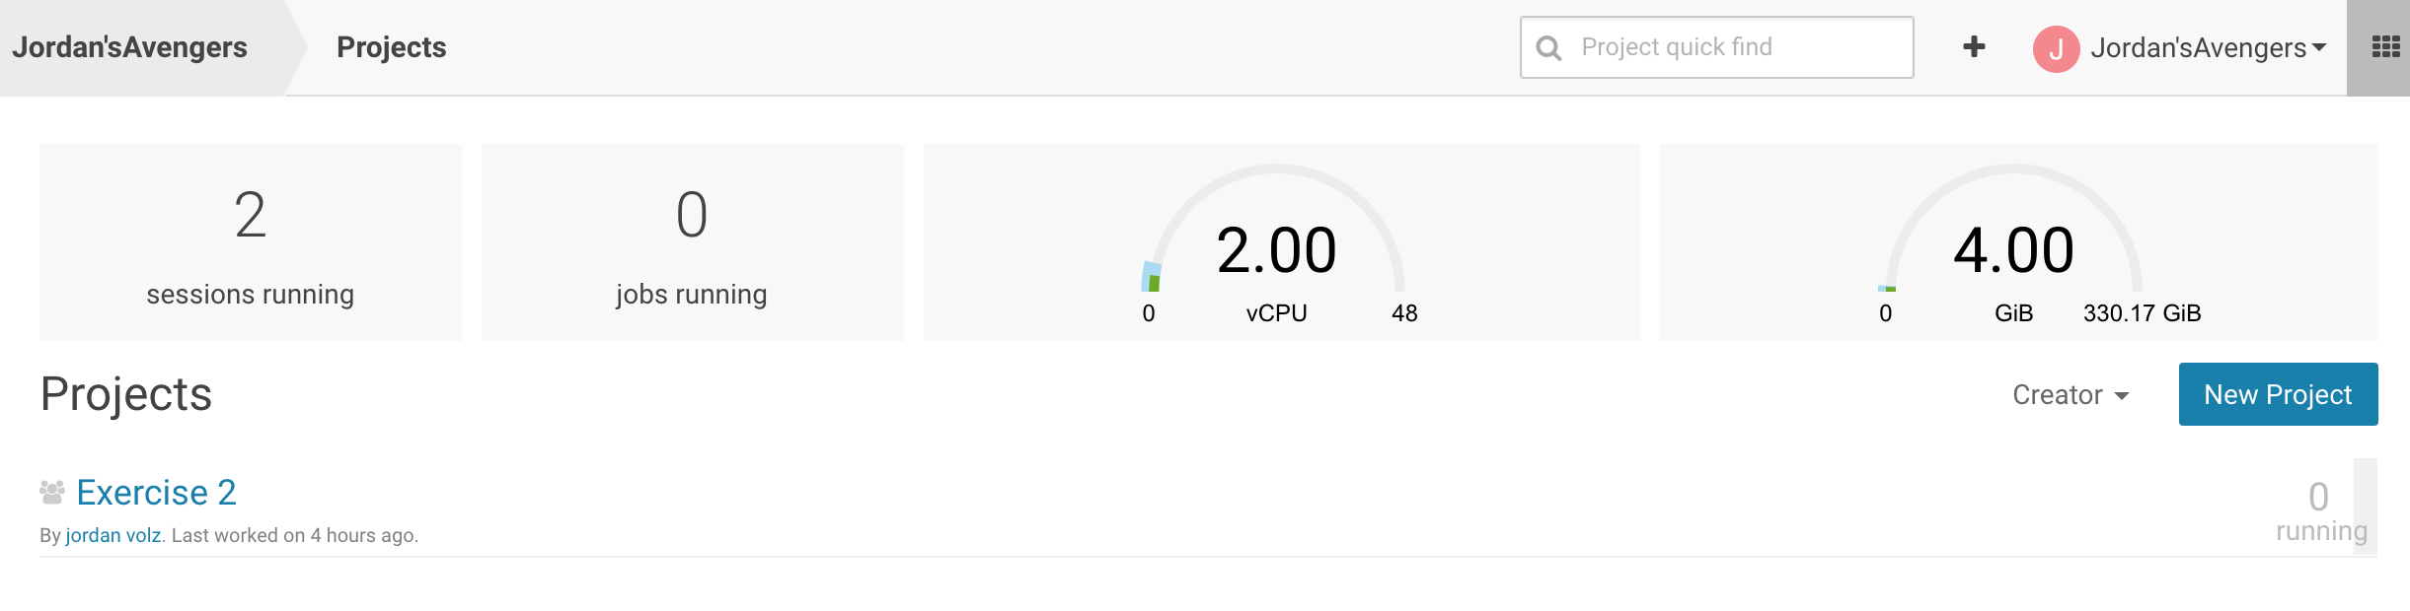

Now let’s stop our sessions to free up resources for others. To do this, we don’t need to return to the project. Make sure you’re in your personal context and navigate to **Sessions** in the left vertical menu. Locate your two running sessions and click stop.

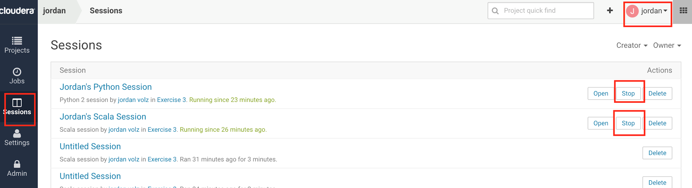

Note that from the Sessions page we can view any of our past sessions by clicking the link.

## Exercise 4: Collaboration via Forking

In this exercise, we’ll look at another way we can create projects – forking them from existing projects in the system. CDSW has a “forking” functionality that allows you to copy, or “fork” a project from one context to another. Although it is possible for multiple users to modify the same project, it can sometimes be confusing if two users are modifying the same file, and generally it is advisable to have users fork their own copy and then use a repository management system like Github as the golden source. CDSW’s forking capability enables this type of workflow, which is popular with enterprise organizations. We’ll take a quick look at how this works.

If you navigate your browser to <http://cdsw.jvolz-cloudera.com/explore>, this will show you public projects in the system. Locate a project called **“US Flight Analytics**” by the user **“jordan”** and open it, or just navigate to this link: <http://cdsw.jvolz-cloudera.com/jordan/us-flights-analytics>.

Click the **Fork** button in the top right corner of the project, then select which team to create the project under, such as the **team you created in Exercise 1**.

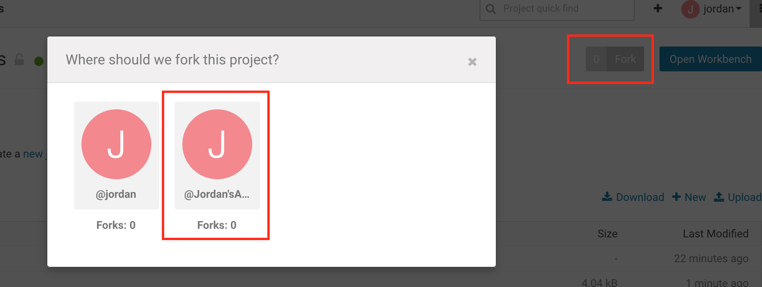

This will copy the project into the new team and load the project dashboard. Click **Open** **Workbench,** select the **flight-analytics.R** file, and open a session with the **R kernel** and 1 CPU/2 GB RAM resources. Click the **Play** button or **Run All** to run the script. This project uses the sparklyR packages to connect to Spark and analyze US flight data. Feel free to browse through it to see what is going on. When finished, **Stop** your session from the workbench.

Before exiting the workbench, inspect the **setup.R** file. The creator of this project has specified a few dependencies that are required to make this project run, which can be installed via install.packages off or CRAN. If you were to create a brand new project and copy the code into it, you would have to setup these dependencies again, which is why the setup.R file exists. In our case, we used **Fork** to copy the project files, including the dependencies, and *did not have to reinstall any packages*. CDSW’s fork functionality copies over the existing dependencies, which makes sharing work easy in the system. The user who understands what dependencies are needed for a project may not always be the one running it, and it can often be complicated to work out what is needed for the code to successfully run. In CDSW, the project owner can work out the dependencies and other users can Fork the work and not have to worry about any of the messy setup.

## Exercise 5: Customizing Projects via Installing Libraries Locally

We’re now experts at understanding how to create and share projects, as well as running code in the system, and we’ve also seen a few examples of interacting with distributed frameworks, like Apache Spark. Let’s take a deeper look into working with dependencies. In the last example, we saw that by forking a current project, we can copy dependencies and not worry about it, but unfortunately that won’t always be the case. Sometimes you may be creating new code that needs certain libraries and you’ll have to work those out. We’ll see how to accomplish this in this exercise.

Make sure all your current sessions are closed, and create a new project entitled “Exercise 5”. You can decide which team to place it under and the visibility. Select “Blank” for the initialization. Open the workbench and select **File** > **New File**, and name the file **plotly_test.py**.

Cut and paste the following code into the file:

dbName = "<Your User Name>"

from plotly.graph_objs import Scatter

from plotly.offline import plot

from pyspark.sql import SparkSession

from IPython.display import HTML

spark = SparkSession.builder \

.appName("%s basketball analysis" %(dbName)) \

.getOrCreate()

spark

## Set up pandas dataframe

pdPlayers = spark.sql("SELECT * from %s.players" %(dbName)).toPandas()

spark.stop

points={ 'data' : ([{

"x": pdPlayers.age,

"y": pdPlayers.PTS,

"mode" : 'markers',

"text" : pdPlayers.name,

}]),

'layout': {

'xaxis': {'title': 'Age'},

'yaxis': {'title': "Points"}

}

}

plot(points,filename="/cdn/%s-bball-plot.html" %(dbName))

HTML("<iframe width=600px height=600px src=%s-bball-plot.html />" %(dbName))

Run the file in a python 2 session. Notice we get an error:

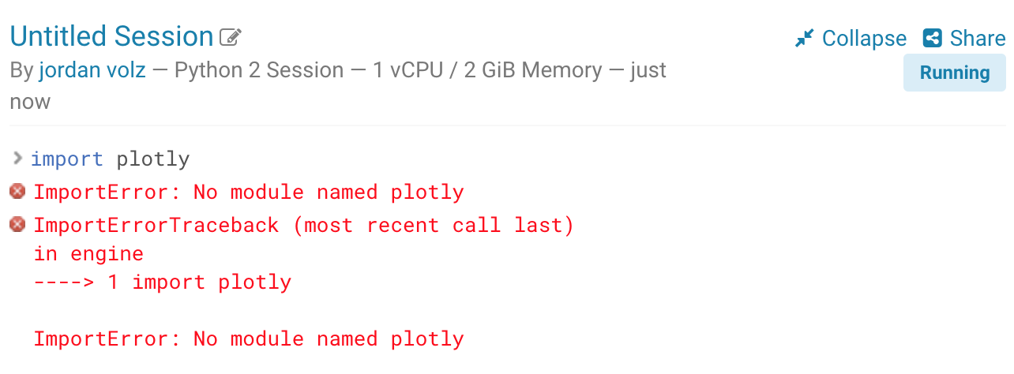

This error tells us that our container doesn’t have the [plotly](http://plot.ly) library. Plotly is a visualization library that creates interactive visualizations and supports online and offline use. Indeed, plotly is not contained in our base image, so we will need to add it. This can easily be done with the following.

Create a new file named **requirements.txt**. On the first line, simply write “**plotly”**. A requirements.txt file is often used with pip to list dependencies. We can install everything in requirements.txt via: “**pip install -r requirements.txt**”. You can either open a terminal session and run that command, or run it in the interactive session by prepending a “!” to it, i.e. “!pip install -r requirements.txt”

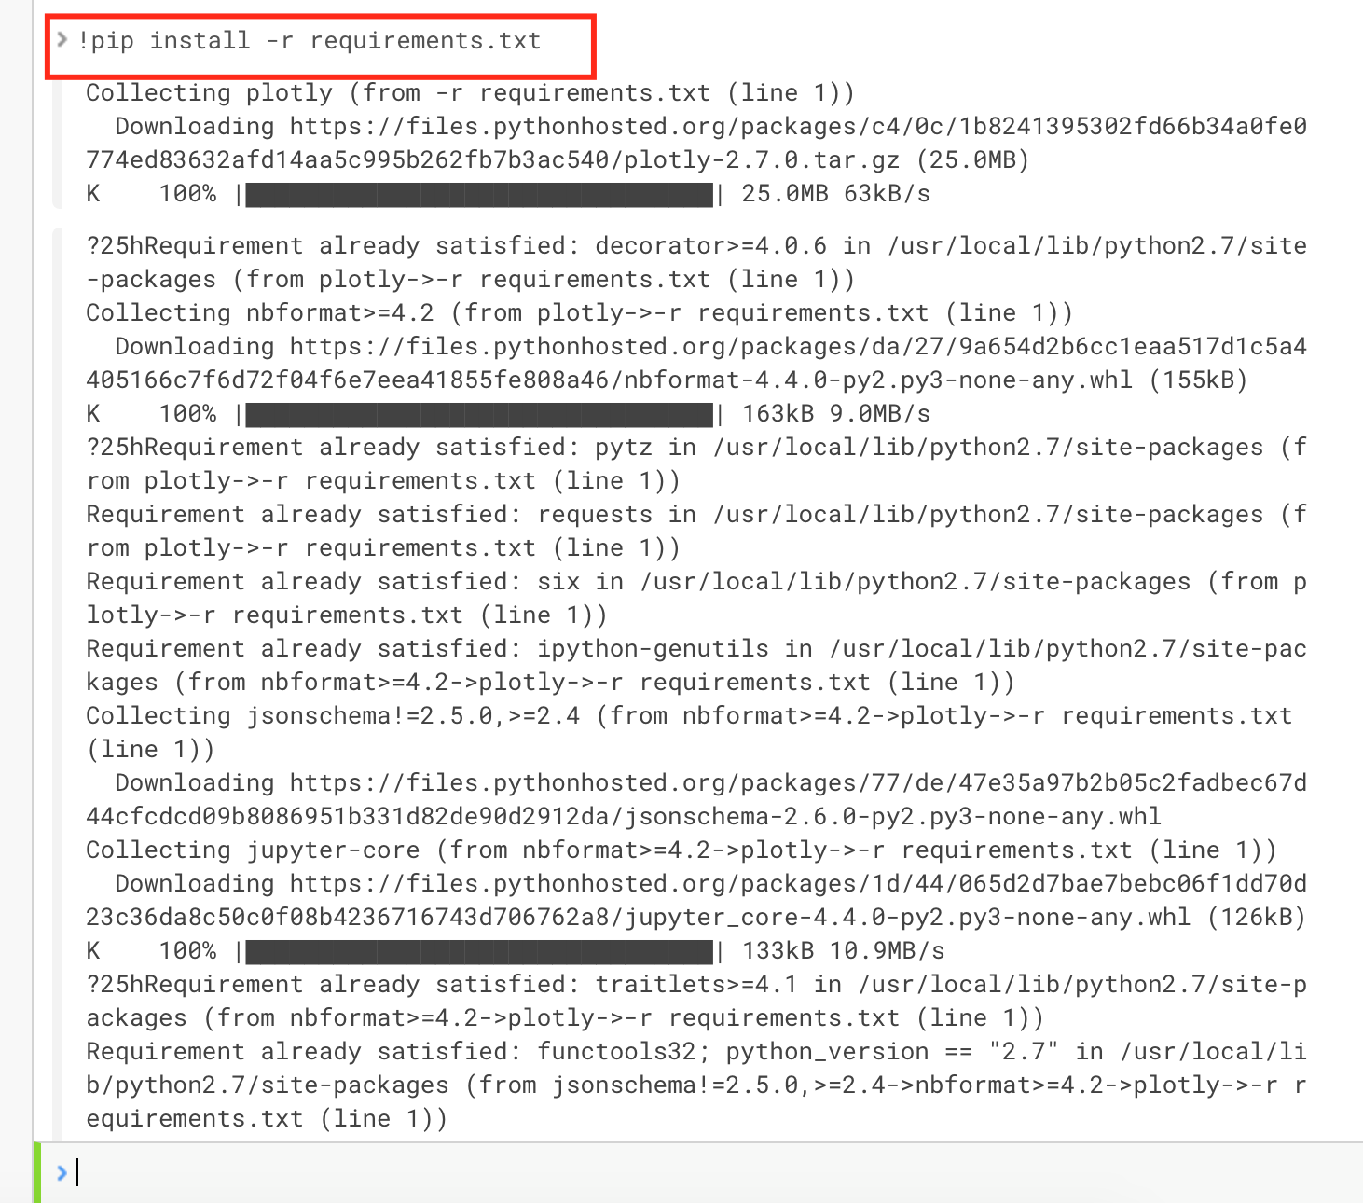

Now try to run your file again. You should now be able to produce an interactive graph, as below.

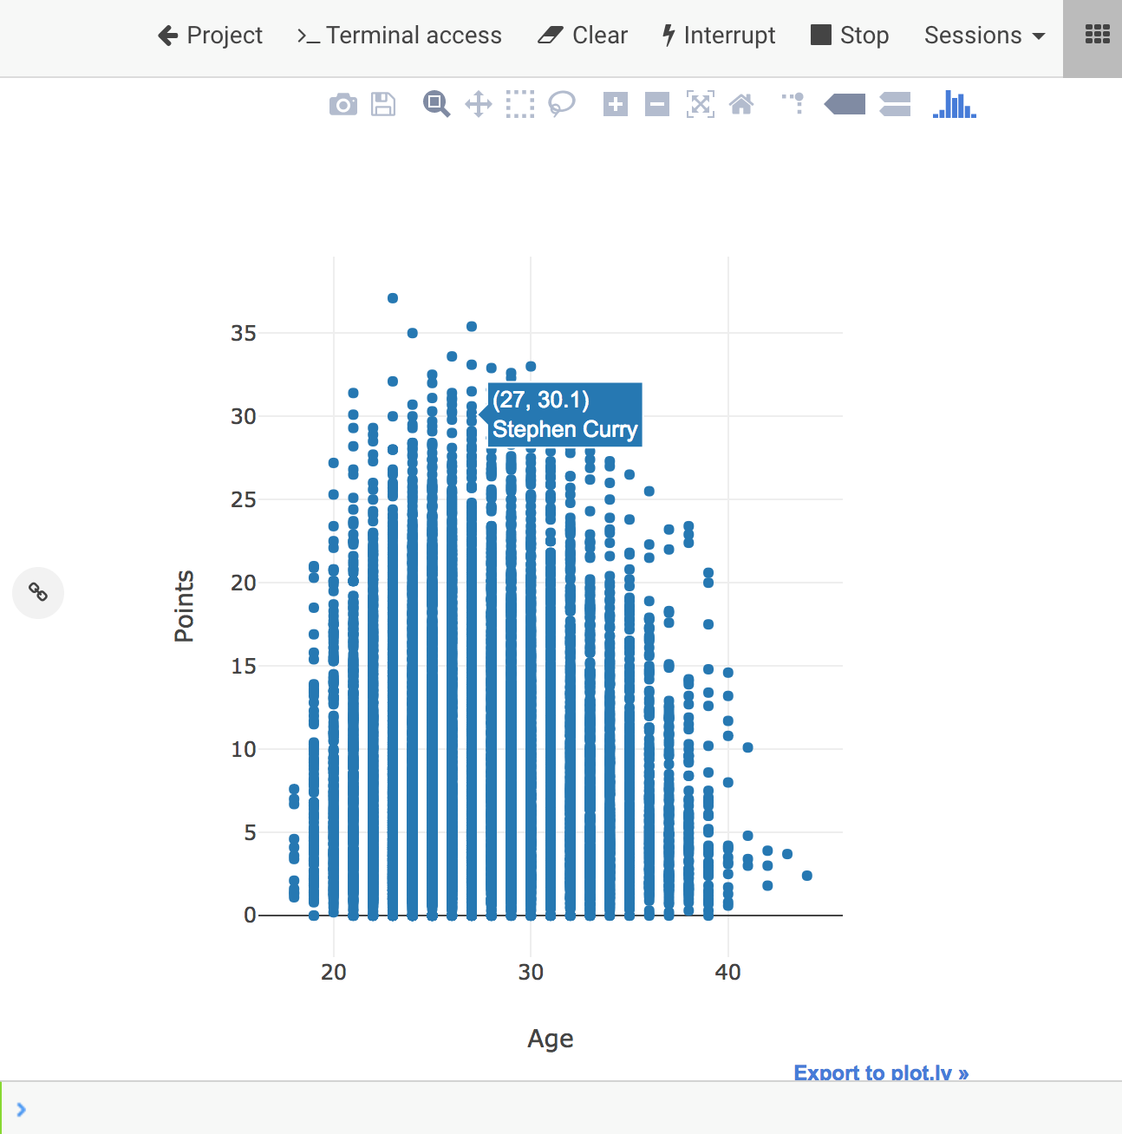

CDSW allows users to install and load libraries using methods they are already familiar with. Python users are likely familiar with tools such as pip and conda (both of which are pre-installed on the base image), and R users should be familiar with CRAN. If your installation of CDSW is connected to the internet, you can pull from public repositories, otherwise you can modify these tools to point to local mirrors. Scala users generally load in their dependencies via jar files, which is also supported in CDSW.

Note that you won’t need to install these libraries for every session. You only need to do it *once* per project. To demonstrate this, close your current session, then open a new python2 session and re-run your code without pip installing plotly. Does it work? It should!

As we saw in Example 5, any forks will automatically carry over these dependencies and other users won’t have to worry about setting them up. Users can customize each project by bringing in libraries they need, when they need them. In the next section, we’ll explore a different method of customizing projects which can be useful when your dependencies exist outside of pip/conda/cran/jar files.

## Exercise 6: Customizing Projects via Changing Project Engines

In this exercise, we’ll look at working with libraries that have advanced dependencies. [TA-Lib](http://ta-lib.org/) is a library used by developers in financial services companies to perform technical analysis on market data. There is a [python wrapper](https://github.com/mrjbq7/ta-lib) for the project, so let’s see if a python user can use this in CDSW.

Make sure all your sessions are closed. Create a new project titled **“Exercise 6”**. Place it into whichever team you want with whatever visibility desired and choose to start from a blank project. The TA-Lib documentation contains a [few python examples](https://mrjbq7.github.io/ta-lib/), let’s see if we can get them to work. Create a new file, called **“ta-lib_test.py”** and past the following into it:

import numpy

import talib

close = numpy.random.random(100)

output = talib.SMA(close)

output

from talib import MA_Type

upper, middle, lower = talib.BBANDS(close, matype=MA_Type.T3)

upper

middle

lower

output = talib.MOM(close, timeperiod=5)

output

Open a python2 session with 1 CPU/2 GB RAM and run the code. You should get the following error:

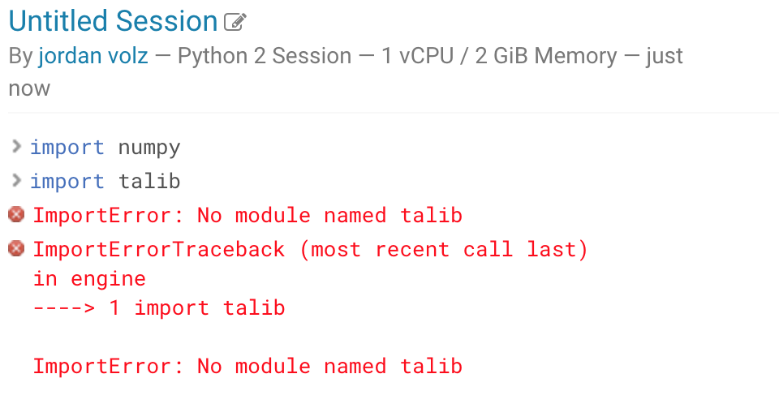

Hopefully this error makes sense after Exercise 5. We need to first install the ta-lib library. As we did in exercise 5, you can create a **requirements.txt** file with “ta-lib” (note: there is a hyphen in the name) or simply issue a !pip install ta-lib from the command line. Do one of those, and you should get an error with the following:

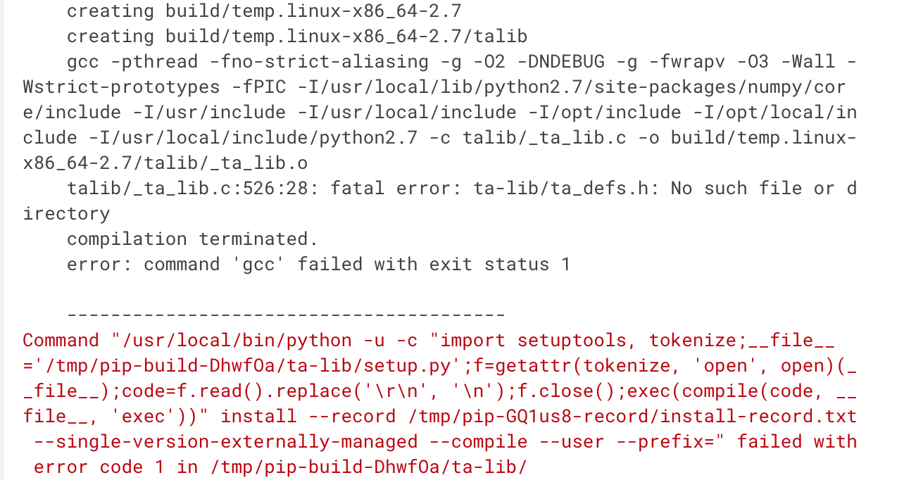

This error message is a little more mysterious, but a little troubleshooting reveals that there is an underlying C++ library that needs to be installed on the host before the python wrapper will successfully install (See, for example, [this](https://github.com/mrjbq7/ta-lib#linux)).

While we have a lot of freedom in our dockerized environment, we don’t have sudo access, so we’re unable to install these libraries in the container. However, there is something we can do to resolve this issue. Cloudera provides a base image for our three kernels, but we also allow users to extend them by installing additional software on top of it and loading it back into CDSW. The process of doing this is outside the scope of this course and requires some working knowledge of Docker. Suffice to say that this is more of an administrative task, and luckily, we’ve already loaded the final engine into the environment for you to use. All you need to do is tell your project to use the new Engine.

We haven’t yet looked at the projects settings page, so navigate there now via **Projects** > **Settings**. Then click **Engine**. Under Engine Image, click the drop down menu and select the Image for **TA-Lib**. At the bottom of the page, select **Save Environment**.

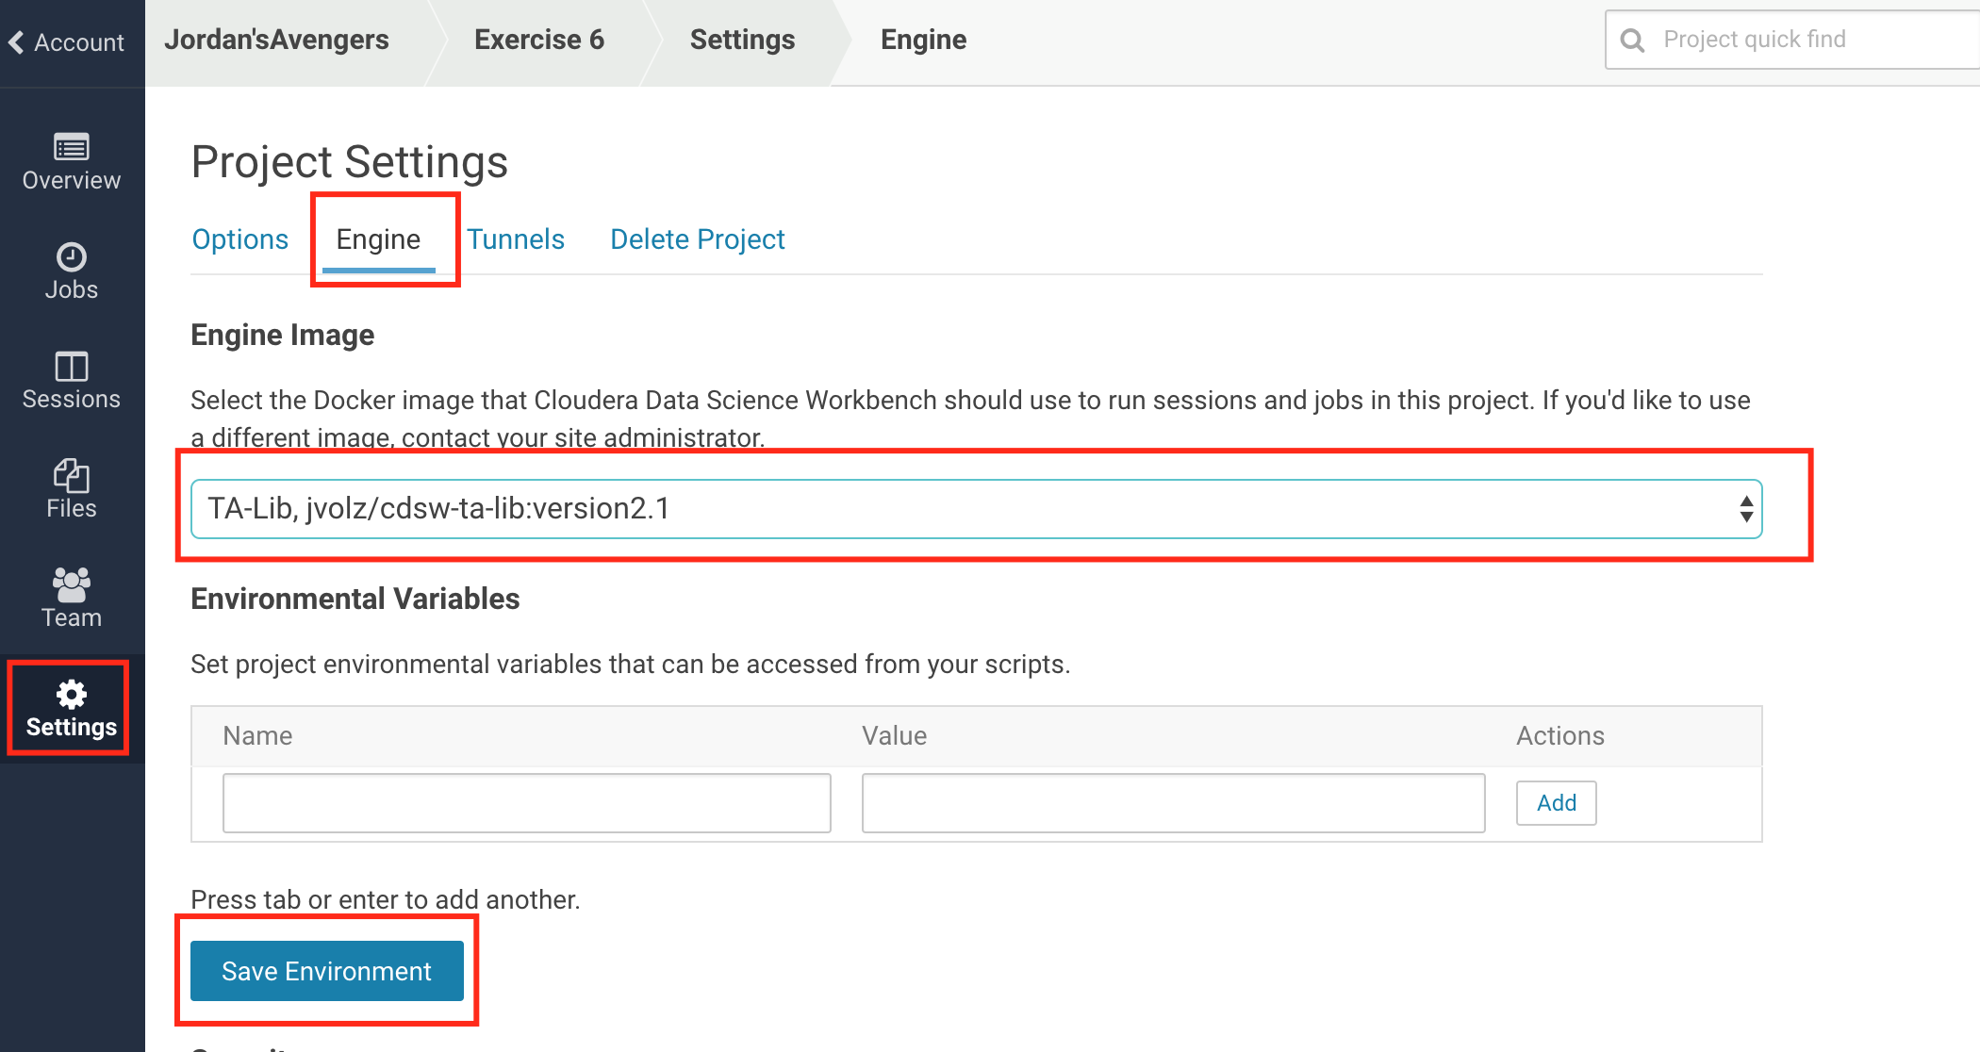

You can now return to the workbench. Note that you’ll need to stop your old session and start a new one in order to refresh the engine. Also, you may notice that when starting a new session, your engine image is now different. There is also a Configure link here that will take you to the project settings if you want a quick way to change the engine image of your project.

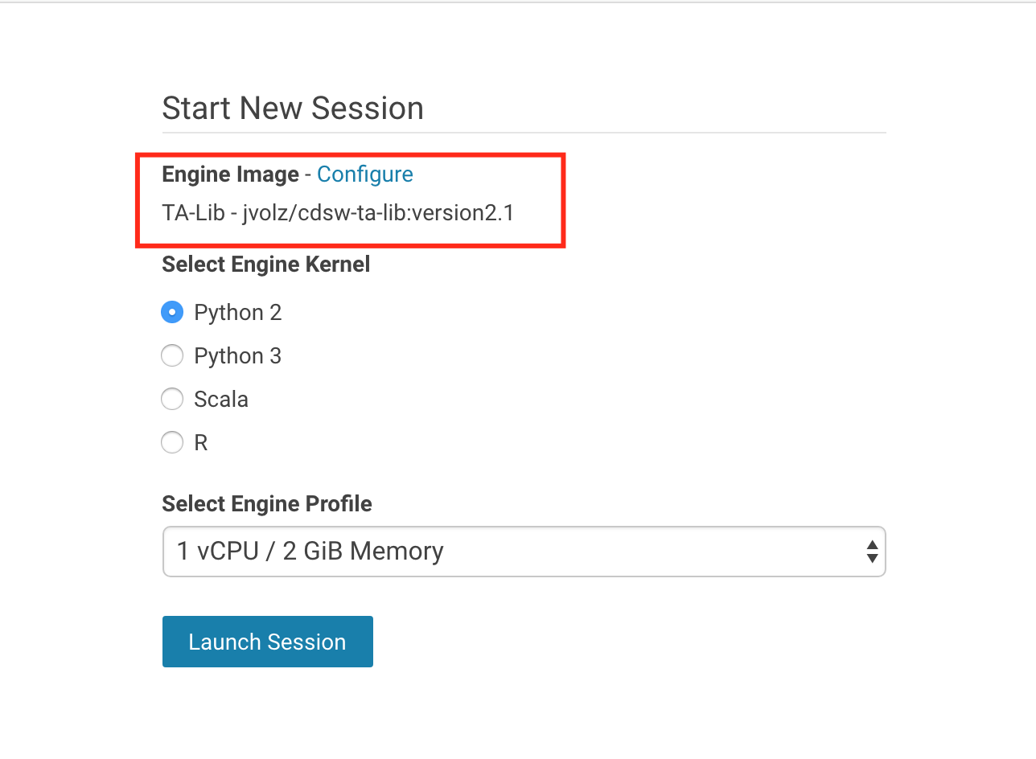

Once you’ve done that (Note: the first time you use a new engine in CDSW, CDSW needs to download it from the docker repository. Docker images can be GBs in size, so it can take a few minutes to start your first session with an image), try to **!pip install ta-lib** again.

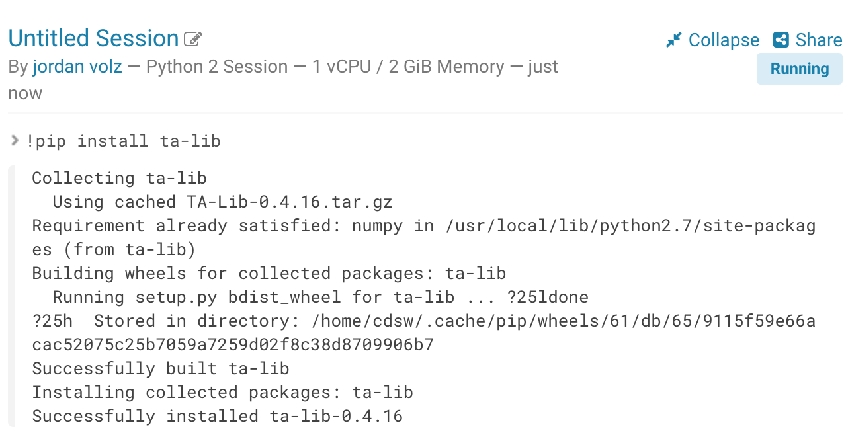

This time we are in luck and ta-lib is installed. Now, run the code to see if it works. This time the code completes successfully:

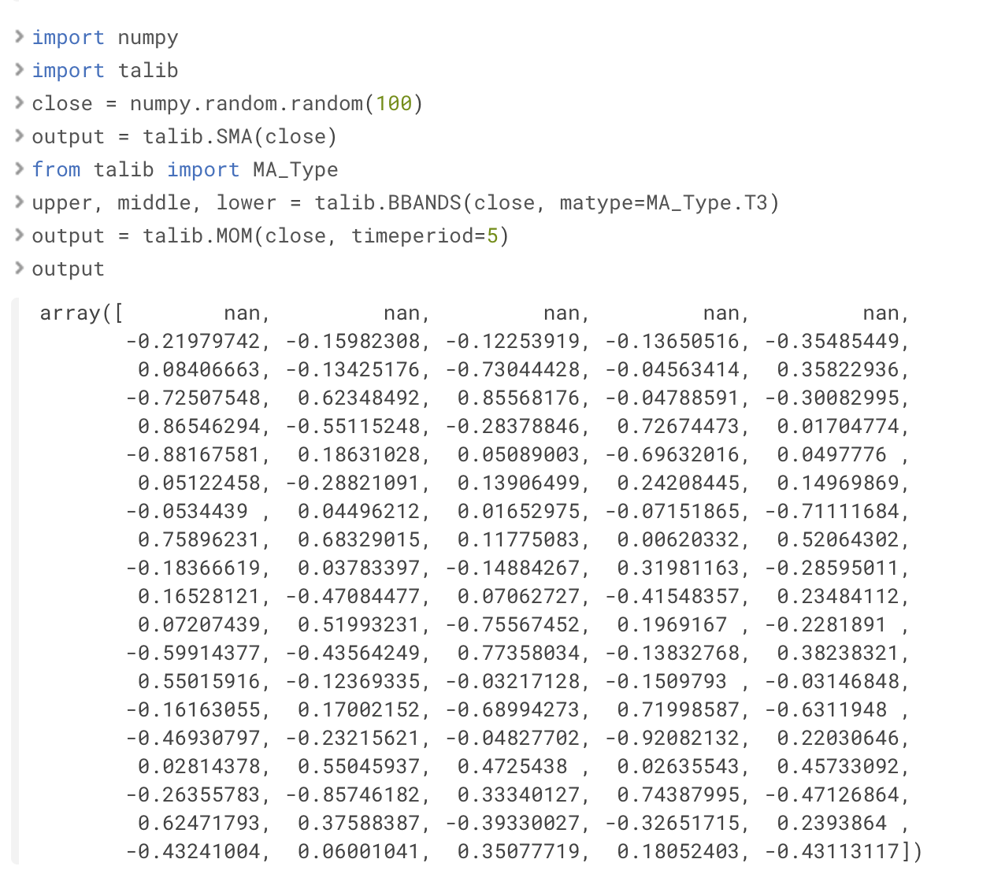

This example demonstrates how users can satisfy advanced dependency requirements via extended engine images and importing them into their projects.

## 

## Exercise 7: Sharing Results

We’re now experts at customizing our projects so that we can work with precisely the tools we need. There’s no barriers now to doing great work with CDSW and the next step is showing off your work to others! In this exercise, we’ll quickly learn how we can share our results with others in our organization.

CDSW makes it easy to share the results of your session. When you have a running session, there is a **Share** link at the top right of the session. Click the link, then “Share With Others” in order to start sharing. CDSW will immediately display some share options, from which you can decide whether you want to make the links available to anyone with the links (aka anonymous users), force visitors to be logged in to view, or specific users/teams who can access the link.

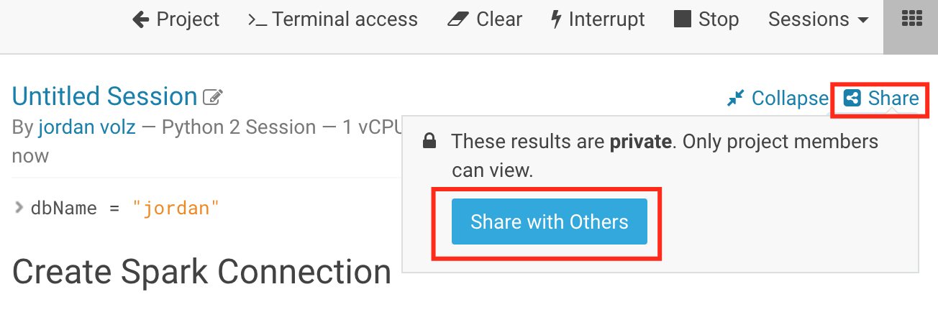

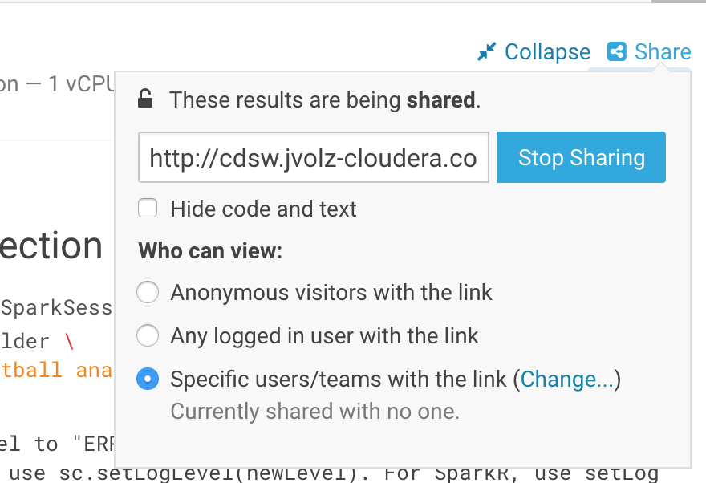

When accessing the link, authorized users will be able to see a static html view of the session.

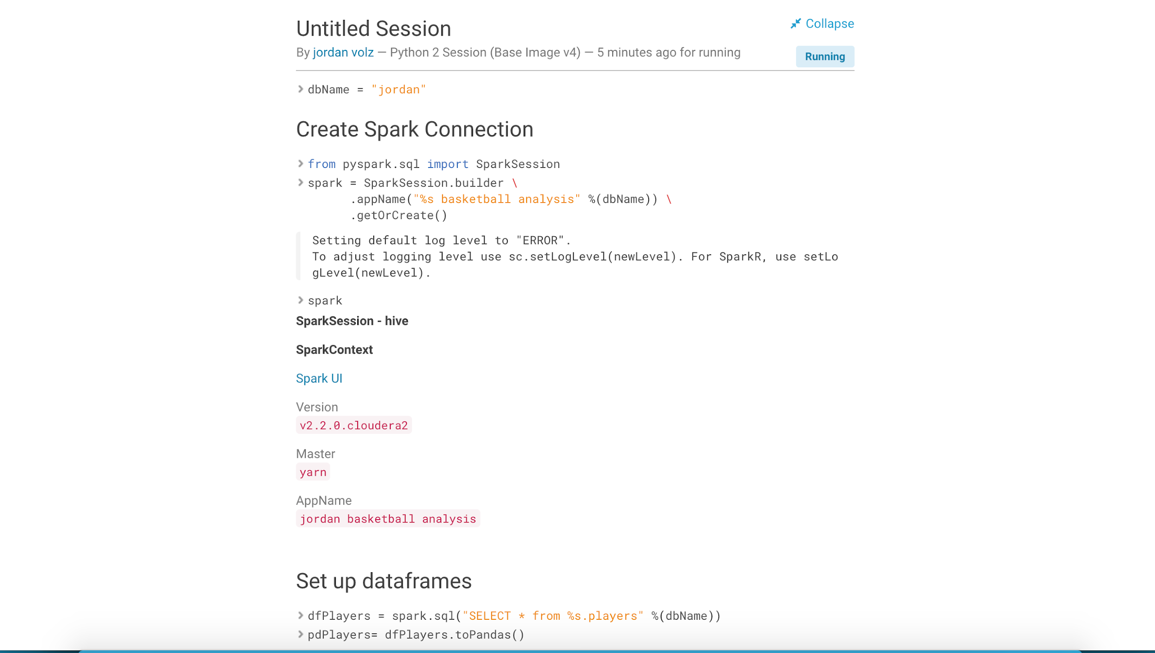

Note that this functionality is not limited to currently running sessions. You may also generate a share link from old session by opening them from the Sessions view and following the same process.

## Exercise 8: Automation via Jobs

The next exercise we’ll look at is looking at CDSW’s job functionality, which allows users to begin automating their code by running it on a schedule. This feature allows users to automate common tasks and chain together different pieces of code to create complex workflows and it is particularly useful for model training and batch or offline scoring.

Open your project for **Exercise 3**. At the top of the dashboard, the Jobs section notifies us that we don’t have any jobs for this project! Let’s fix that by click on **Create New Job**.

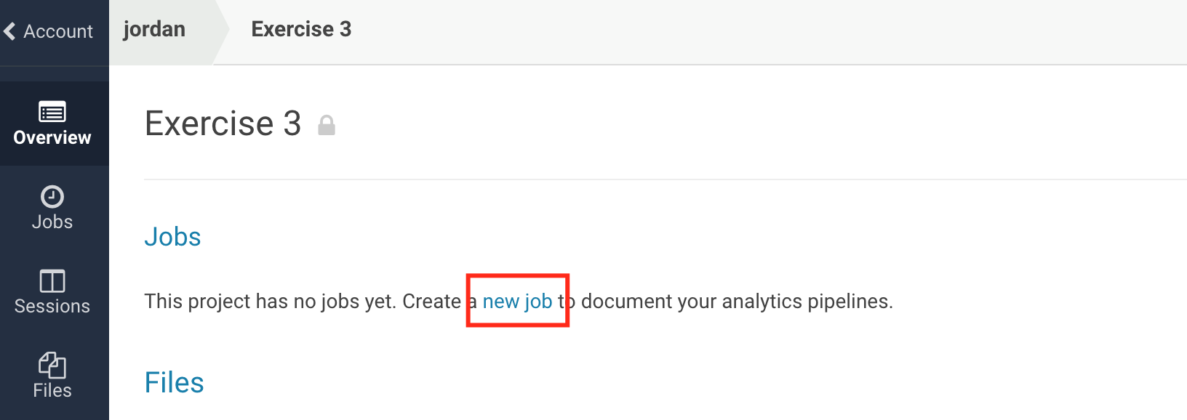

CDSW will pop up a form to fill out to tell it what you want to run and how you want it to run. This is very similar to creating an interactive session, as your job will also run within the CDSW engine in a Docker container.

Give the project a name, such as **“<Your User Name> Data Processing Job”**. Next, select a script from the project that you want to run. In this case, select **data_processing.scala**. Now, select the Engine Kernel to attach to the Docker container, **Scala** in this case. Choose a schedule to run on. Select **Recurring**, choose every **Day**, and select a time of day. Next, select the 1 CPU/2 GB RAM engine profile for the resources. This is all that is required. Optionally you may do things like specify Environment Variables for the project, specify job report recipients, and modify the timeout limit. Scroll to the bottom and click **Create Job**.

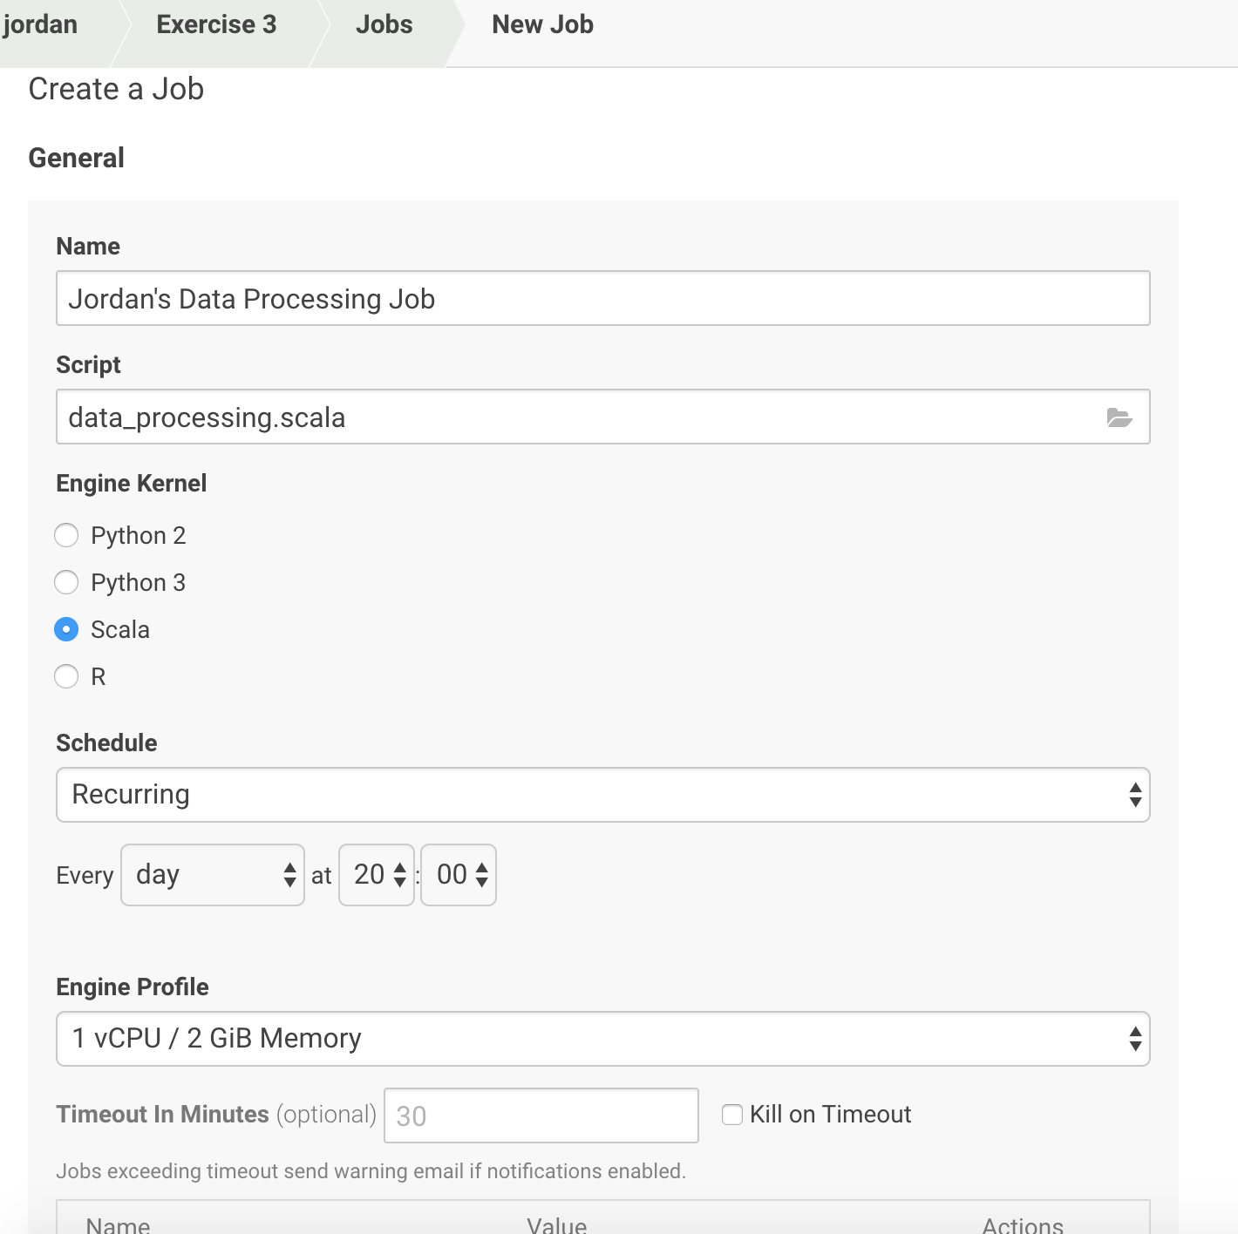

Now we have 1 job! Before we run it, let’s connect it to a second job. Click **New Job** in the top right corner and let’s create a second job. This time, we’ll create it based on the **analysis.py** script, and we will schedule it to be **dependent** on the first job we created. Your job should look something like below. When finished, click **Create Job**.

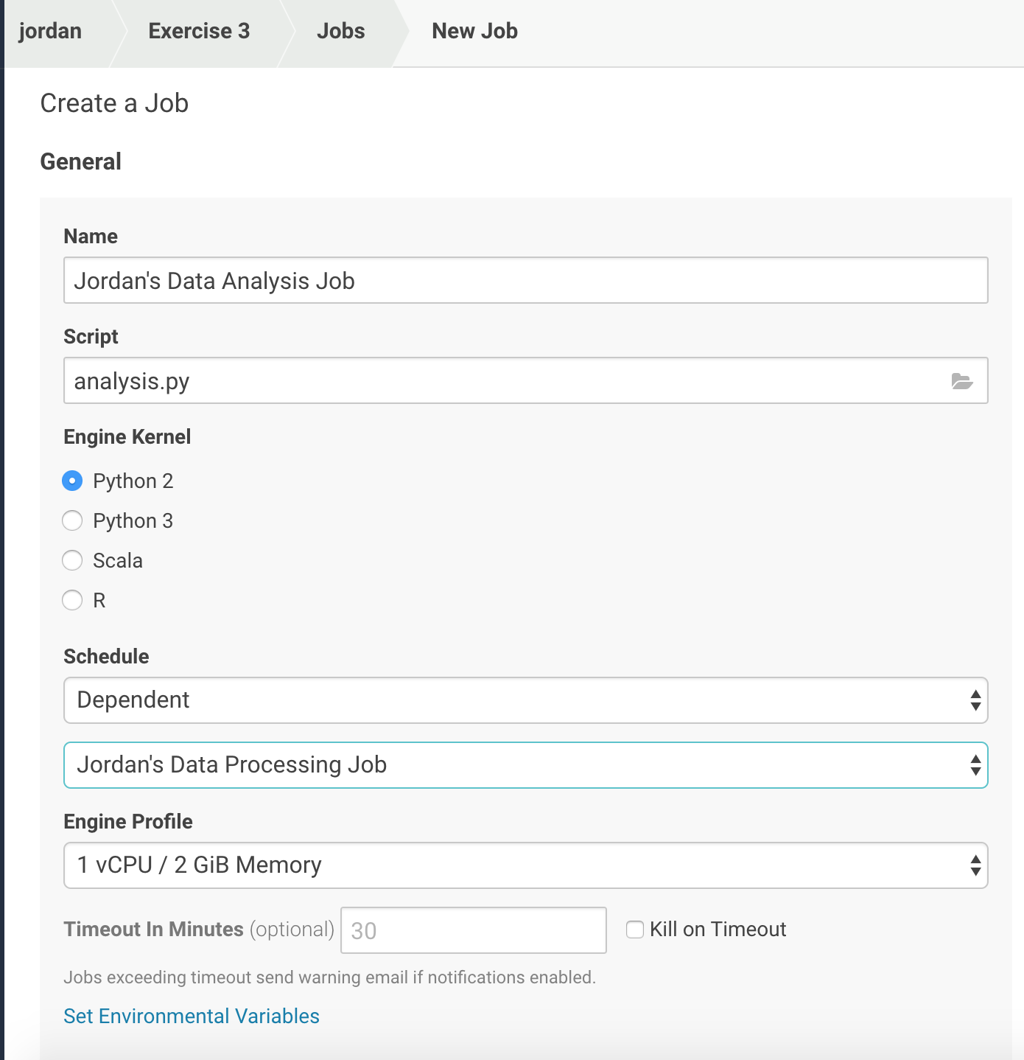

Since we created a dependent job, we notice that our jobs are connected in a chain. The chain doesn’t have to be 1-1. We could, for example, have many jobs dependent upon a parent job, which would then branch off with different actions. If you don’t want to wait for the scheduled job, you can run your jobs ad-hoc from the jobs page. Press Run next to the job **“<Your User Name> Data Processing**”

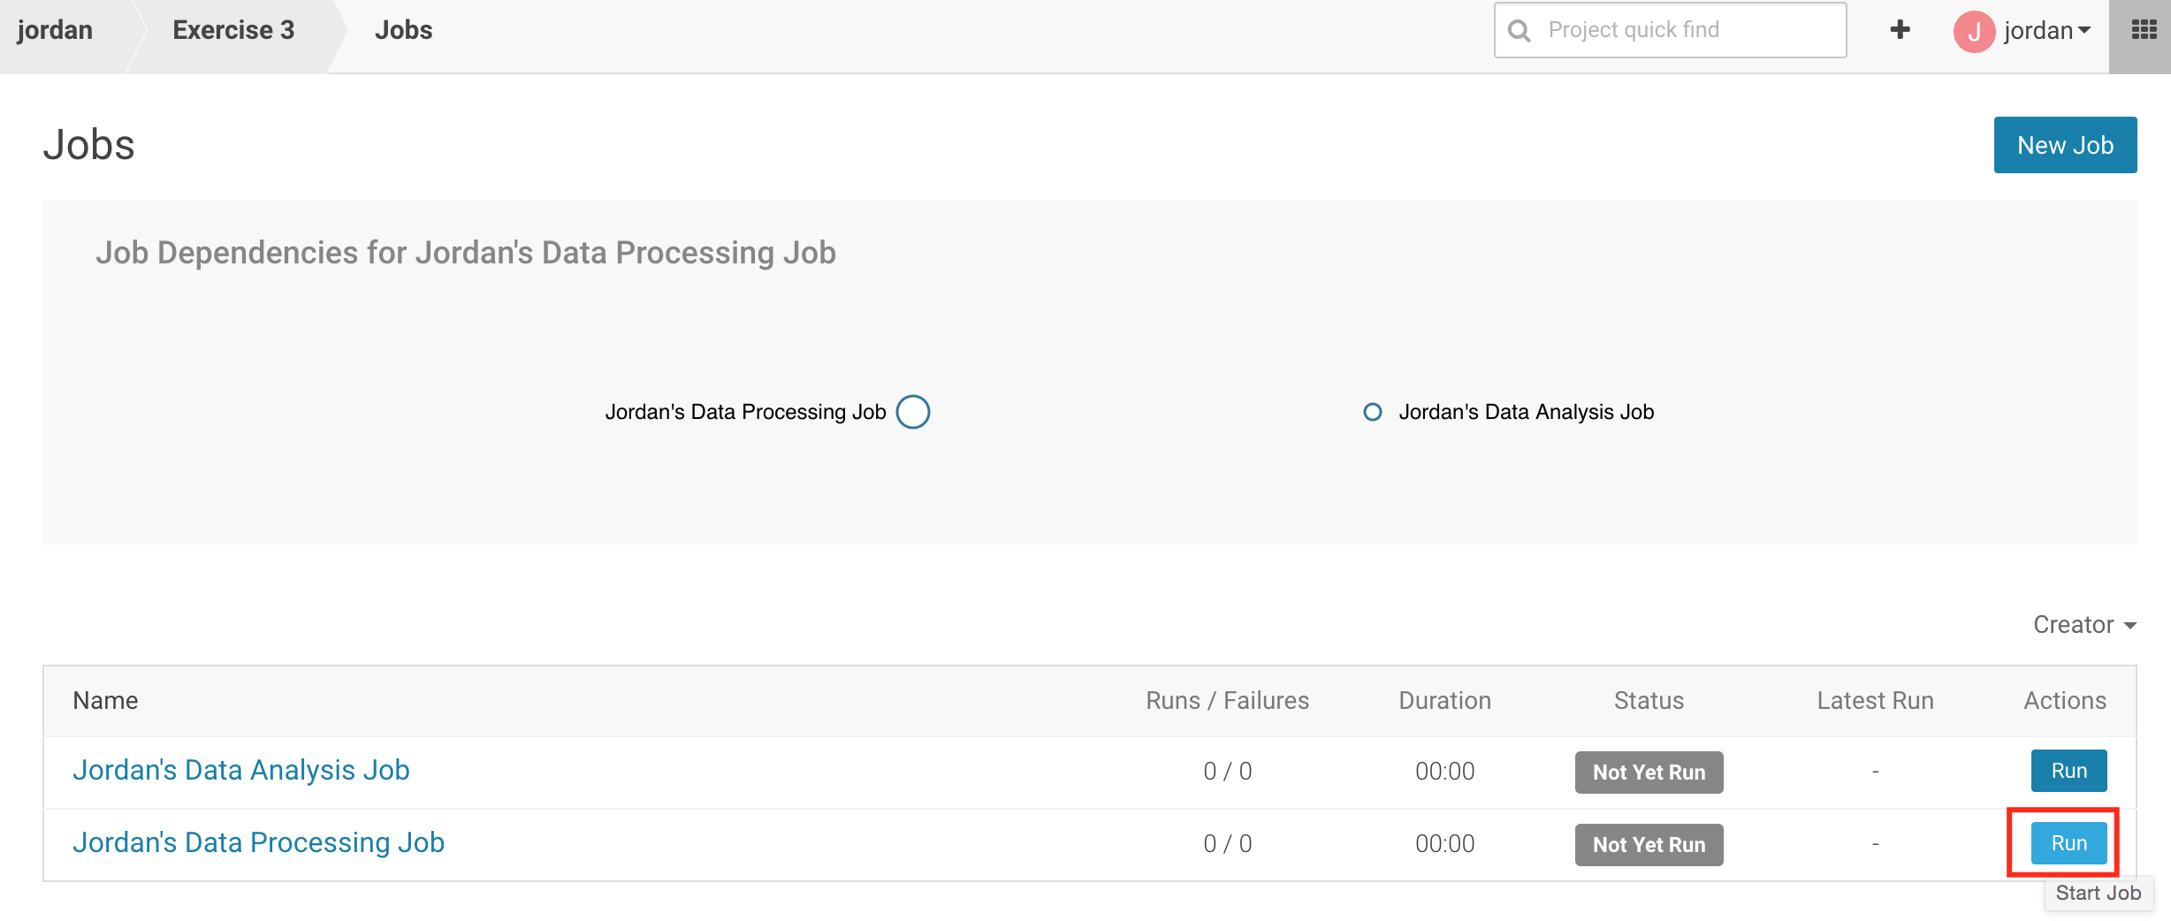

It should take approximately 2-3 minutes to run through both jobs. When they are finished, click on the **Data Analysis** job to drill into the details. As your job runs, you’ll generate a graph that details the duration of each run, as well as whether or not it was successful.

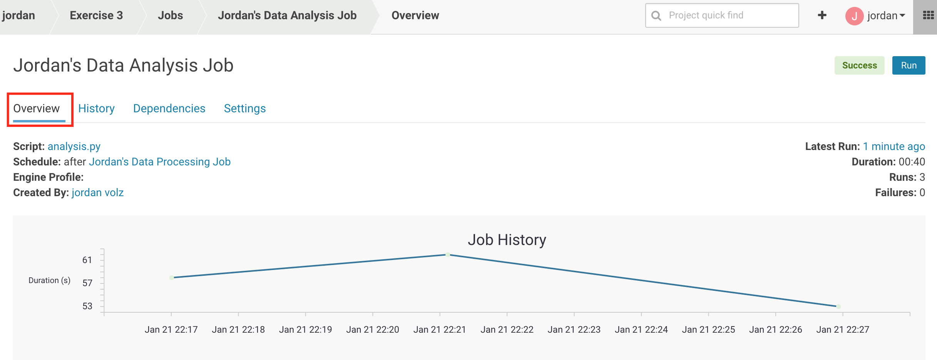

We can get a table view of this via the History tab, and for any run we can drill down into it to see the output of the job.

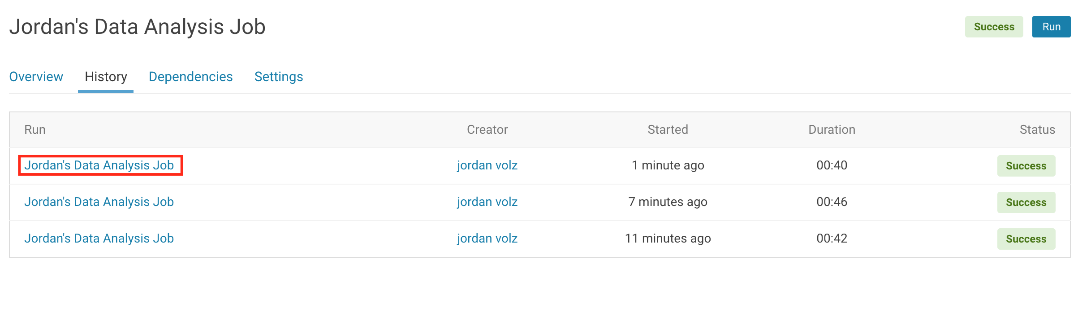

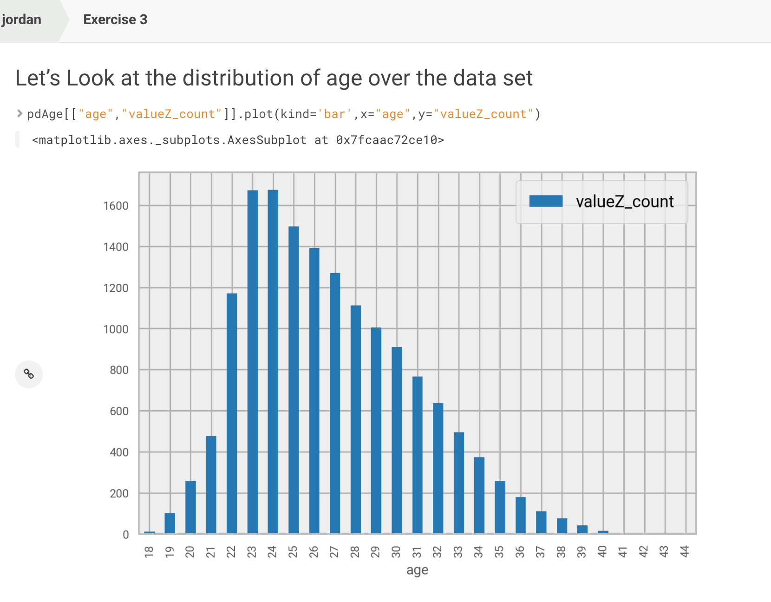

The other two tabs allow us to view the job dependency graph, as well as updating the settings for the job.

Note that the job functionality may also be called via the [Jobs API](https://www.cloudera.com/documentation/data-science-workbench/latest/topics/cdsw_rest_apis.html). This can be useful in connecting CDSW processes to external tools. For example, you may have an ETL pipeline that ingests data into the cluster and then runs a job in CDSW to kick off batch scoring of the new data set with an existing model.

## Exercise 9: Experiments (CDSW 1.4+ Only)

If you’re using CDSW v1.4 or above, you’ll have access to the new features *Experiments* and *Models*. In this exercise, we’ll look at the experiments functionality.

Navigate back to your dashboard and create a new project using the github repo: <https://github.com/jordanvolz/dsfortelcoCDSW>. After the project has been cloned, navigate to the workbench and run the **setup.sh script**. This will perform a few preliminary actions that will make our project ready to use. Click on **dsfortelco_interactive.py** and run this file. This project takes a sample telco dataset and creates a pyspark model to predict customer churn. This file takes you through a standard explorative practice including data visualization and feature selection. Feel free to read through it if you are interested.

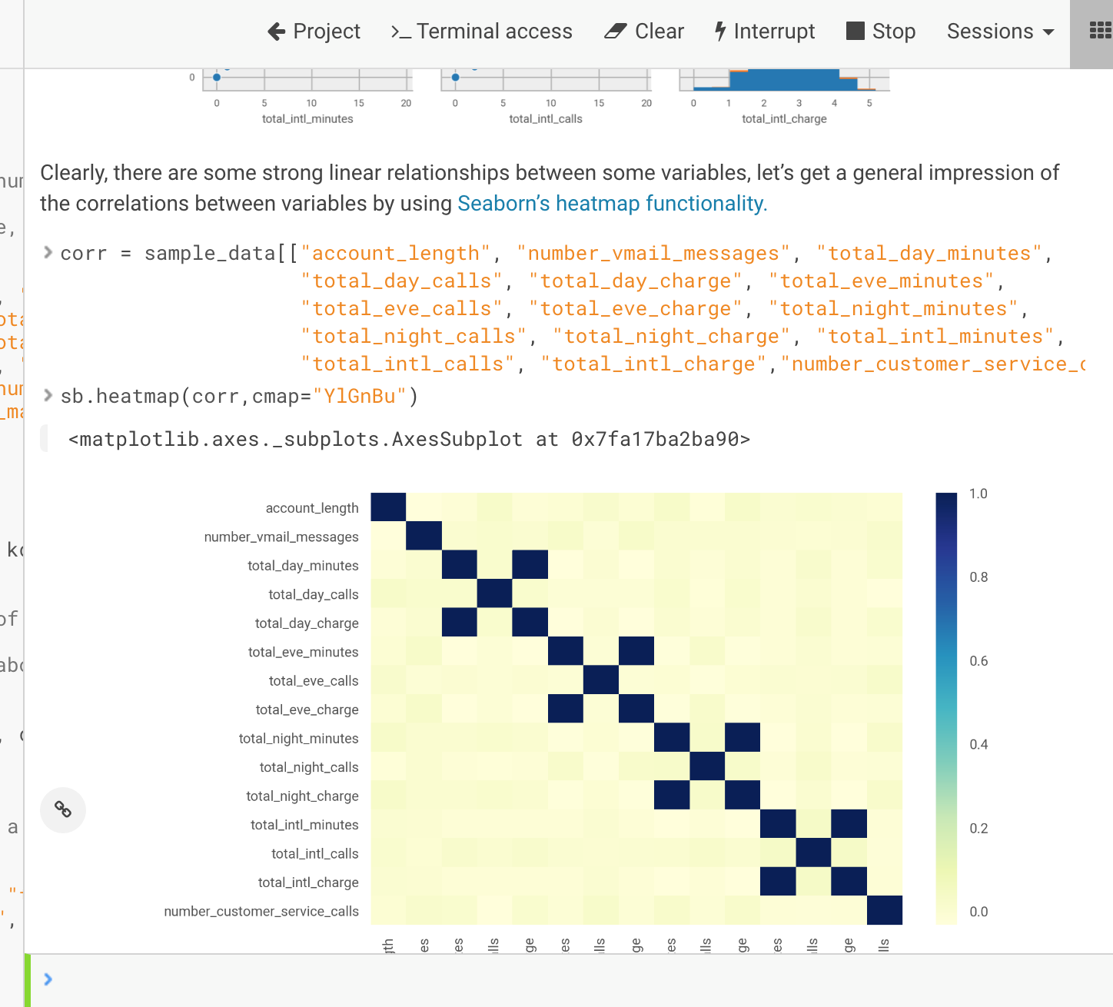

Now we want to start creating experiments. Experiments allow you to start creating versioning runs of your project and tracking metrics, which makes it easy to compare models and reproduce prior results. To get started, select the **dsfortelco_pyspark_exp.py** file to open it in the editor. This is a very similar file to the one we just ran, but we’ve modified it to run as an experiment. Scroll down halfway to the bottom and you’ll notice some changes that we have brought in.

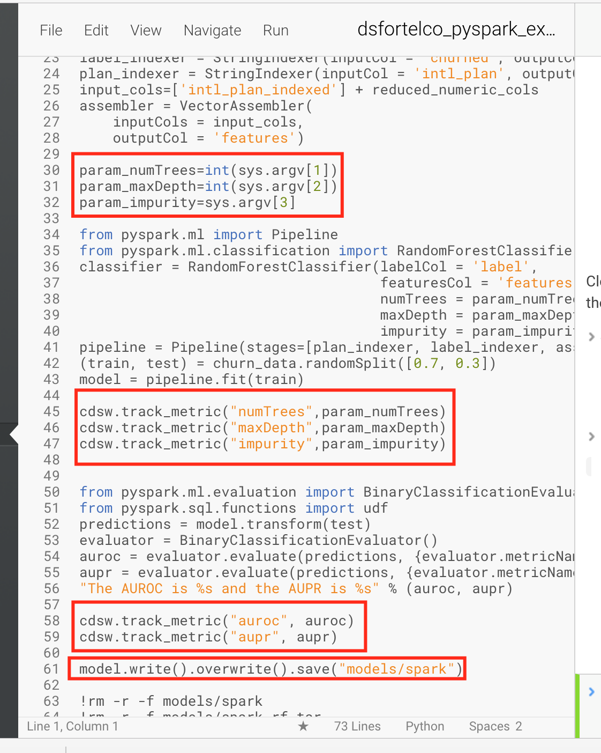

Experiments take arguments as an input which you can access in your code (via sys.argv). This allows you to reuse the same piece of code and plug in different arguments, like parameters, so that you can quickly iterate over a model in many different runs. You can also track different variables in files in your model with the cdsw library. All you need to do is import cdsw and utilize the cdsw.track_metric and cdsw_track_file commands to associate those with a run. Note that experiments don’t inherit all the libraries you’ve been installing in your project. It’s common that you’ll install many libraries in a project to experiment with different approaches, but we want our actual runs to be pretty slim. As a result, the runs only use the base engine, but you can also provide a cdsw-build.sh file that will execute commands during the build step. This can be useful if there are dependencies you want to install for your experiment (for example, you may want to pip install -r requirements.txt, where requirements.txt tracks all the libraries needed for your experiment!).

To start running experiments, click **Run > Run Experiment.** This pops up a window that allows you to specify the environment in which to run your experiment.

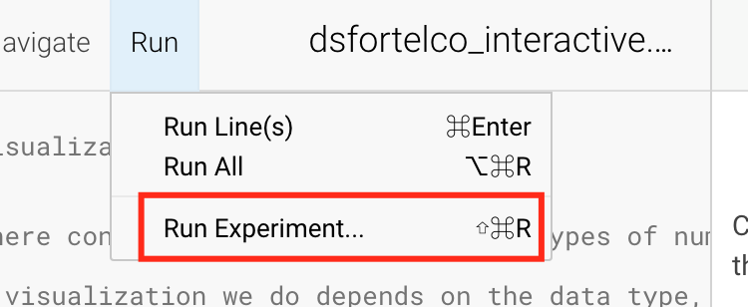

The file is auto-populated with the open file in the editor. Enter “10 10 gini” as your arguments for the run, and select a small python 2 engine to run it in. Then click **Launch**.

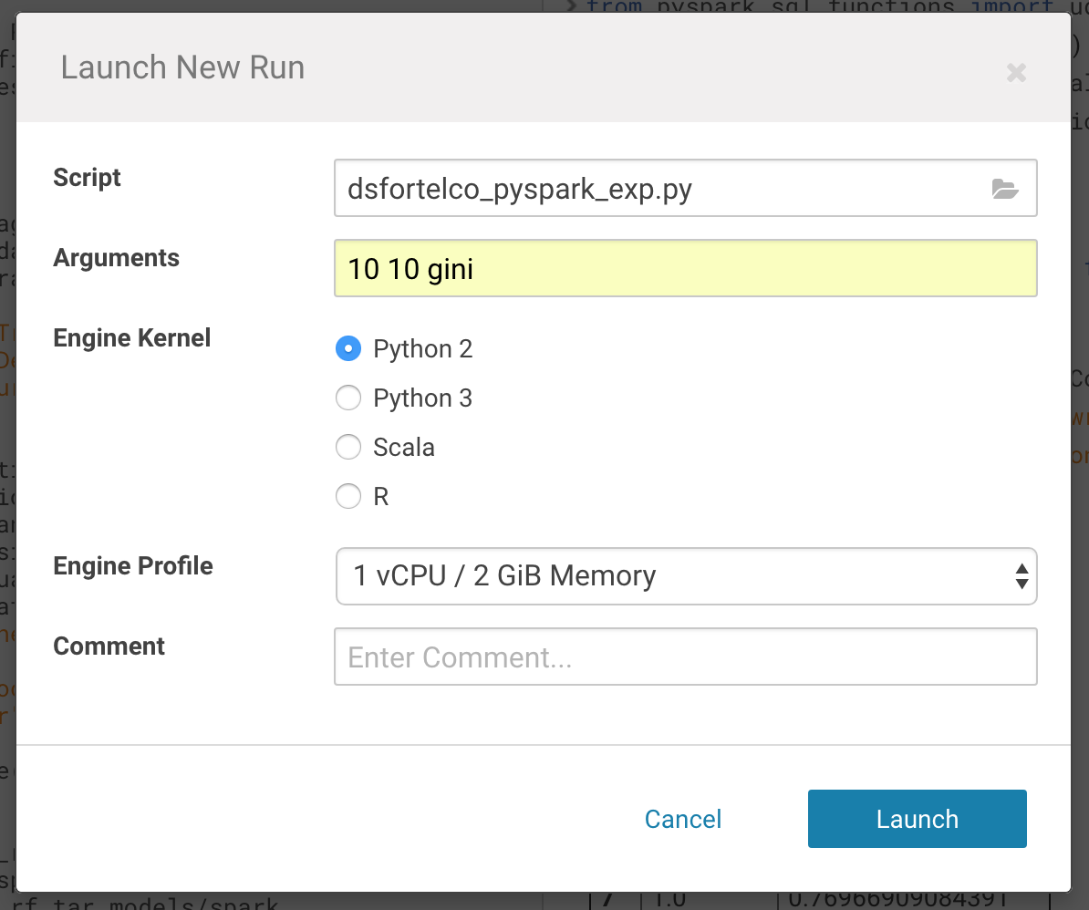

You can now view the experiment by navigating back to the project overview and clicking on **Experiments**. This takes you to a list of all the experiments run. You should see your experiment at the top of the list, along with the metrics that you are tracking (Note that you can select which metrics to display via the dropdown menu on the top right).

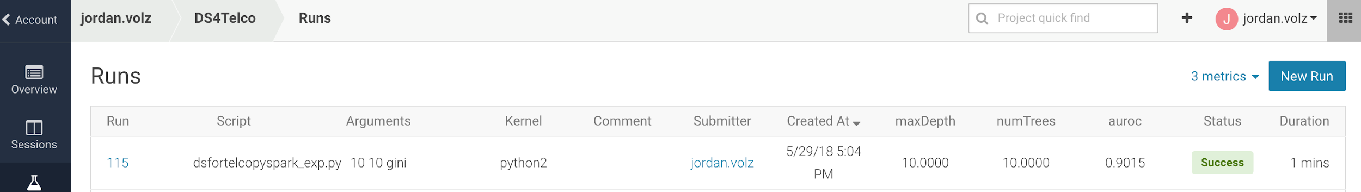

We want to compare our pyspark model to our sci-kit learn model, so let’s generate a new experiment. We can actually kick off a new experiment directly from this page, just click **New Run** at the top of the page. Now choose the **dsfortelco_sklearn_exp.py** file, and fill I similar information to the previous run. When the experiment finishes, you’ll be able to compare the two runs. The metric that is most interesting for our example is the area under the ROC, and we can quickly discern that our pyspark model does a little better than the sci-kit learn model.

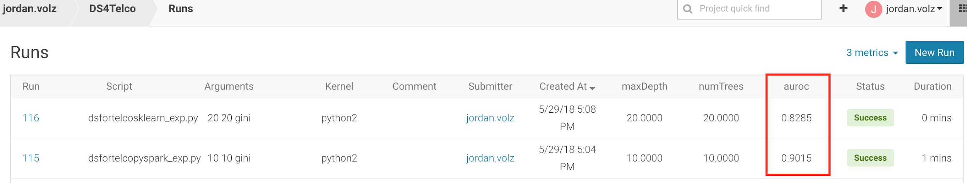

We can drill down into any model by clicking on the Run number in the leftmost column. Click on the pyspark model run to see it’s details. The next page shows an overview of the model. Se can see the script run, the snapshot created, as well as the metrics and files tracked. For any file tracked, we have the option of saving it directly to our project. This can be very useful if we experience regressions in our model and want to revert to an older artifact. Since the runs are snapshotting and we are tracking files, we can copy it back to the project and deploy it back out as a model (which we’ll learn how to do in the next section!). If interested, you can also view the console output of the experiment, or the build output.

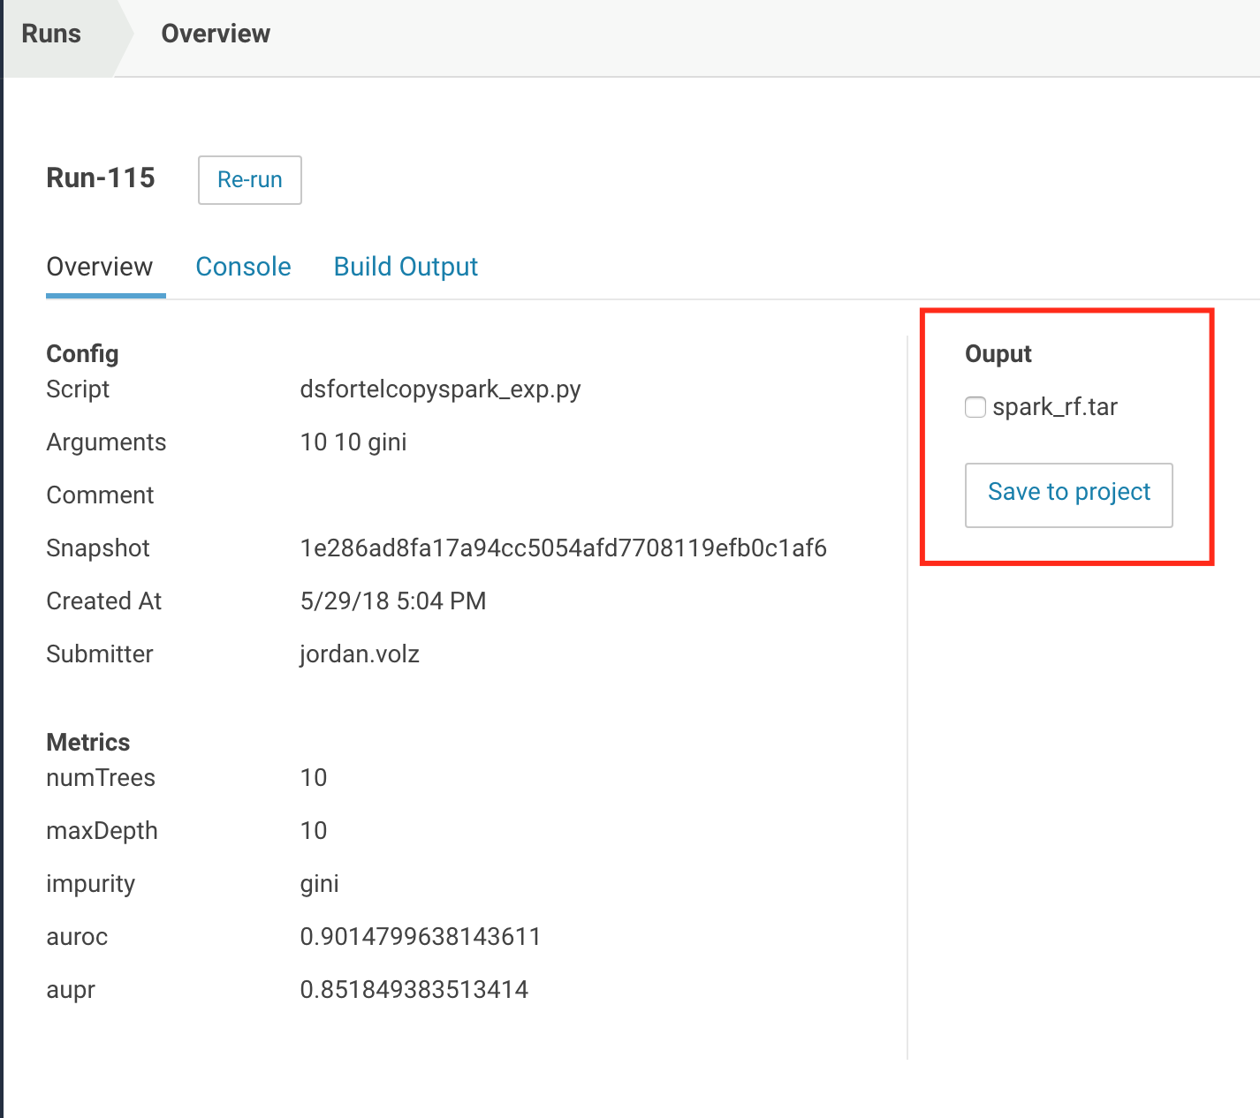

Click the spark_rf.tar files and select **Save to Project.** Select the Overview menu and notice that the spark_rf.tar file is now in your project.

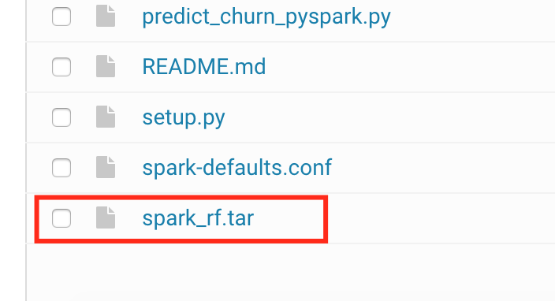

## Exercise 10: Model APIs

The last exercise we’ll look at is using the Models API to host a model endpoint for online scoring. Before we create a new model api, let’s open the workbench and open the **predict_churn_sklearn.py** file. This is a very short script that loads a model (from a pickle file, created from the **dsfortelco_sklearn_exp.py** script) and defines a predict function that takes a feature as input and runs it through the model function.

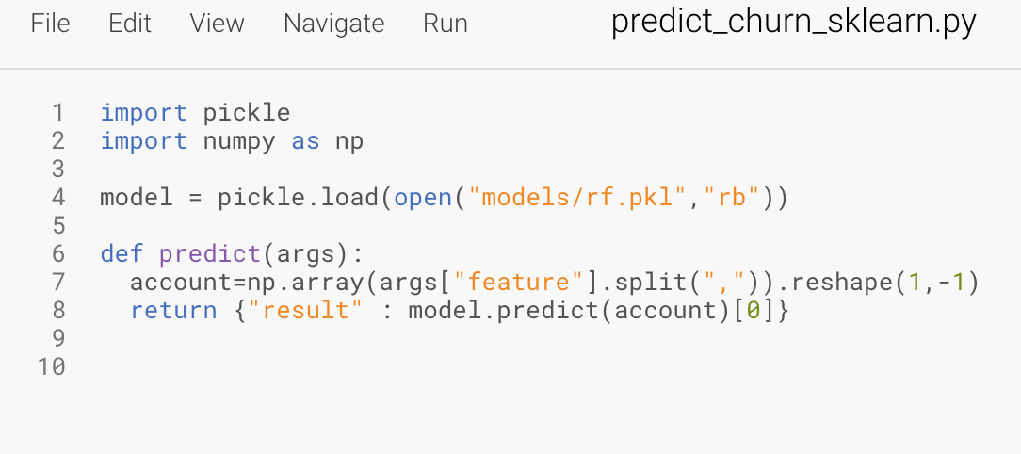

This is a simple function, but it will do just fine to illustrate the capabilities of the Models API. Navigate back to the project overview page and click “Create a new model”.

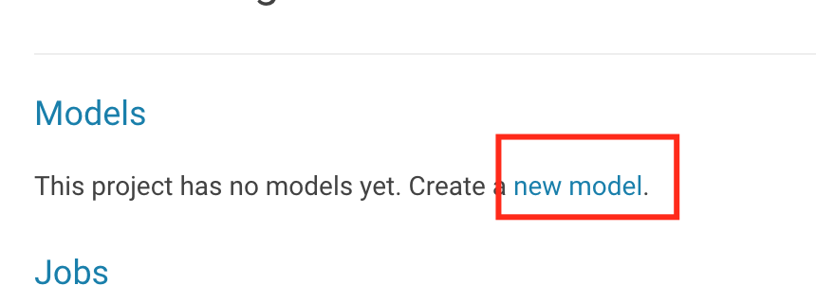

On the new page that pops up, you’ll give the model a name and description, then define the build. For the build, you give it a script and the function in that script to run as an API (such as **predict_churn_sklearn.py** and **predict**). Additionally, provide a sample input and output in JSON. In our example, we input a feature vector and will output a churn prediction (0 for false, 1 for true). Lastly, define the engine kernel to run it in as well as the profile and number of replicas. Replicas allow you to create multiple copies of the model, so that if one should fail, the others will continue to serve results.

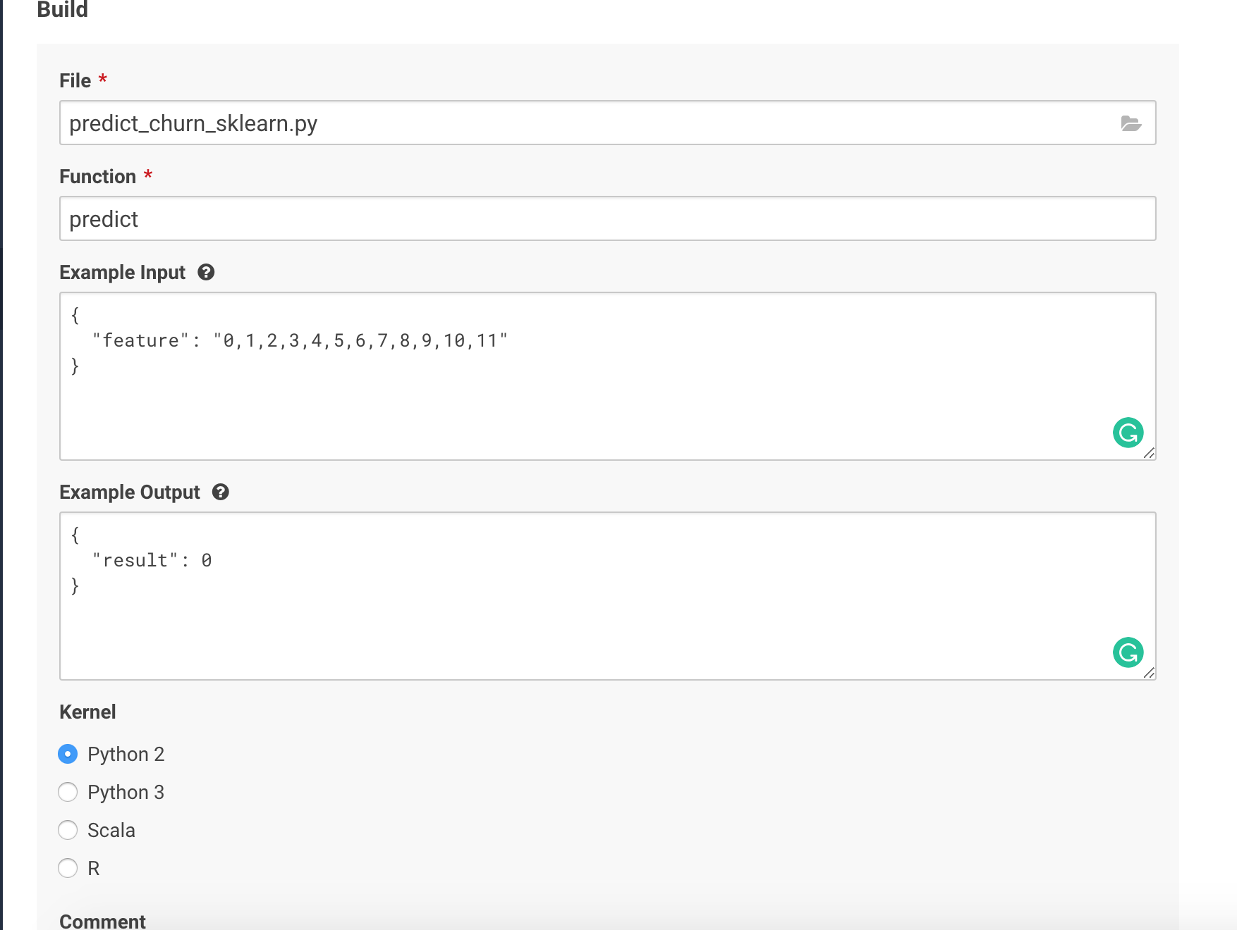

When finished, click **Deploy Model** at the bottom of the page. You’ll now be at the Models dashboard. It should take a few minutes for CDSW to build the environment for your model, but when finished, you’ll notice that the model’s status is “deployed”

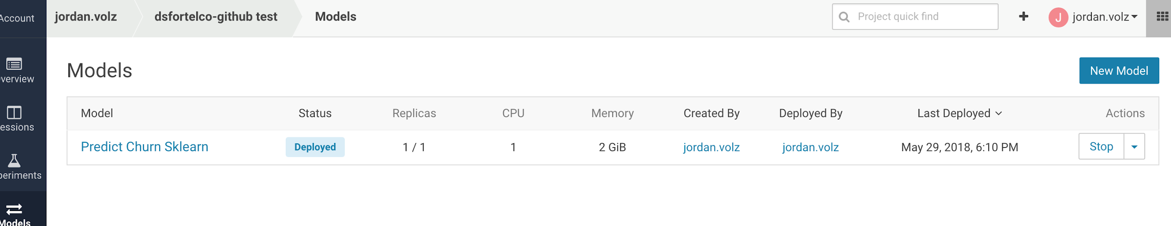

The dashboard gives you an overview of models you have in your project and their status, as well as quick way to start/stop models or deploy new builds or new models entirely. Click the model you just created to drill down into it.

The overview tab gives you information on the model – what build it is deployed, what file is being used, what function in that files, system resources, etc. On the bottom, you have a quick box to test the model itself. Feel free to modify the input values and then click **Test**. Below, it will display the output of the model (0 or 1 in this case).

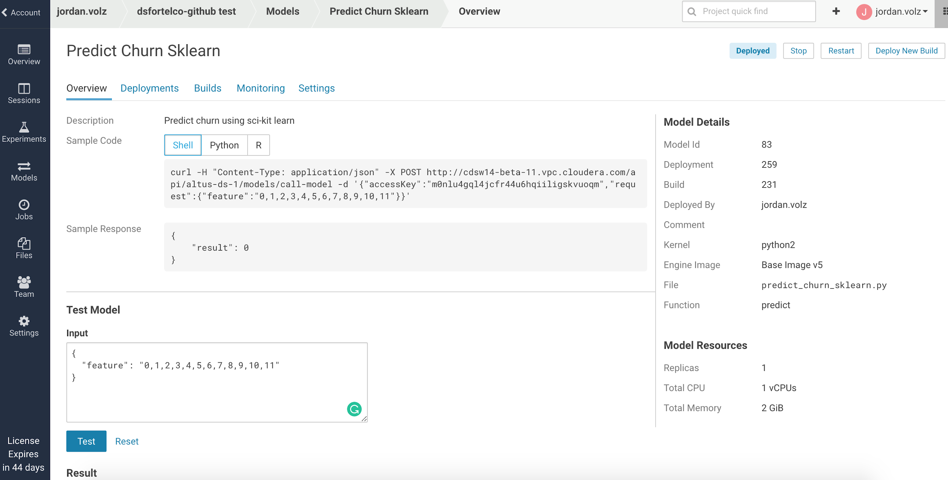

Typically, you’d utilize the model in an application that would use the API to generate real-time predictions. The top of the page provides a few examples of working with the API, via shell, python, and R. Copy the shell command, open a terminal on your laptop, and run the curl command. You should get back a JSON result like the following:

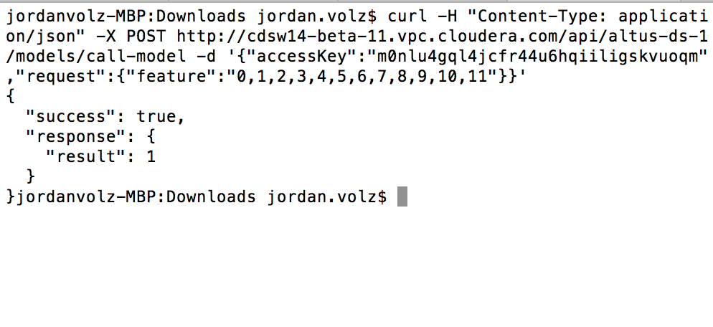

The next two tabs in your model keep track of deployments and builds. *Builds* are needed anytime a physical change is made to your model. I.E. your scoring function changes or you make a change to the model itself. *Deployments* are just instances of the model running. You may only need to run a model during certain times of the day, so you can shut it down when it’s not used.

Note that you can view old deployments and re-deploy old builds. This can be crucial if you make a change to a model that has an unexpected consequence. Instead of wondering how to get back your old model, you can simply navigate to the deployments tab and re-deploy an old version. You can also create a new build at any time as well.

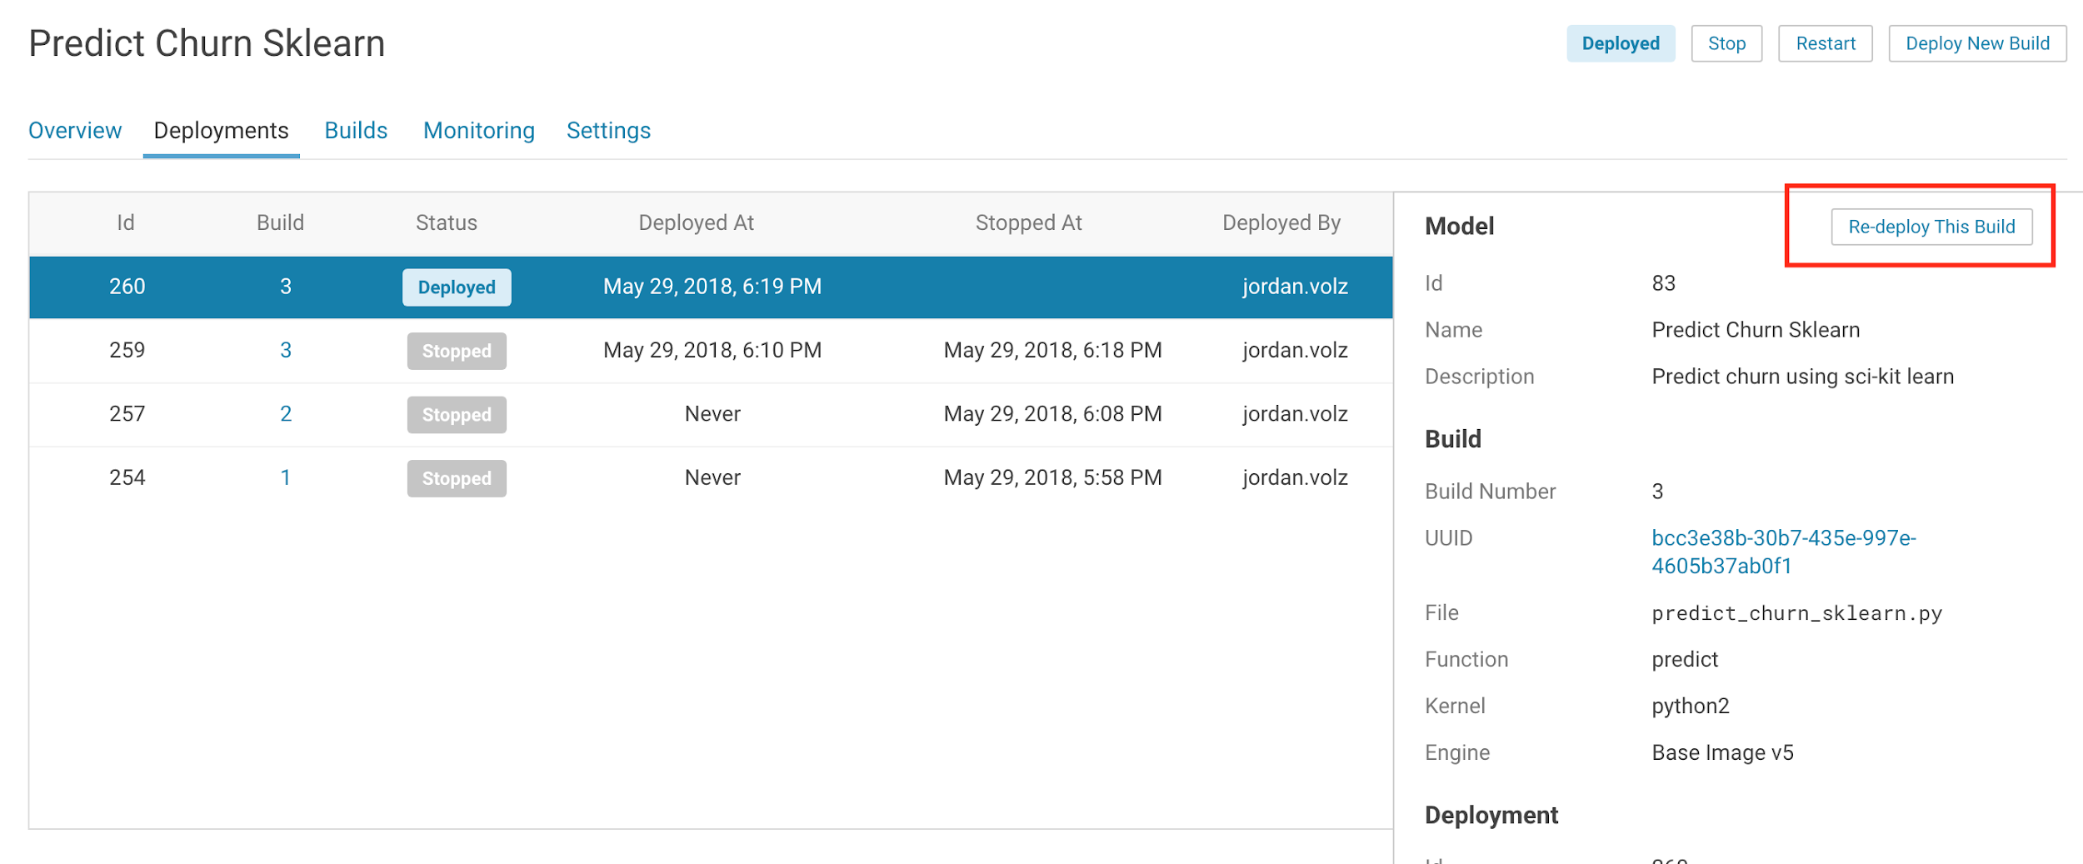

The *Monitoring* tab keeps track of the currently deployed model and bubbles up some statistics about how it’s being used. Here you’ll be able to see how it’s handling various requests that come in.

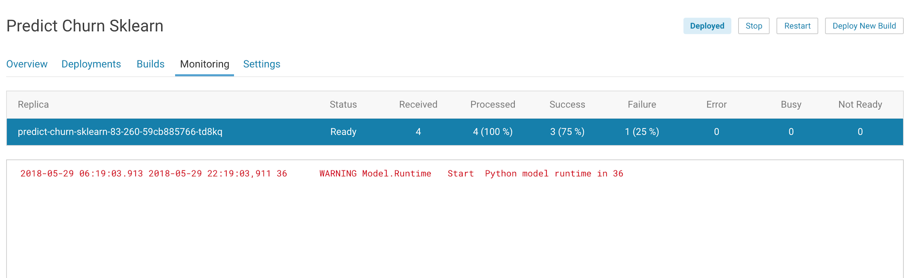

Feel free to play around with the model deployment feature. You may also want to try building a model for the pyspark model we created in the previous experiment!

## Exercise 11: Free Time!

Congratulations! You’ve finished the CDSW walkthrough. You now have a strong grasp of the functionality of the tool, and how it can be used with the CDH cluster. Feel free to use the remaining time to experiment with the tool as you see fit. We’ll include a few suggestions below for projects that may be worth considering, and there is also some content in the Appendices. Let us know if you have any questions.

1. **Intro to Spark**: <https://github.com/jordanvolz/Intro-to-Spark>  
   For those looking to get into distributed processing, Apache Spark is the go-to tool in the CDH stack. Learning spark is far outside the scope of this tutorial, but we have a gentle introduction on github that was actually designed to be run in CDSW. Feel free to create a project with it and explore if if you want to learn a little bit more about how Spark can be leveraged with CDSW. Note that the cluster we’ve provided doesn’t have all CDH components installed and not all the subsections of this project will be able to complete. Contact the instructor if you have issues with anything.
2. **DS for Telco**: <https://drive.google.com/file/d/0B0we1KVH_icsODhIc0tySjdYelk/view?usp=sharing>

This is the project the instructor went through in his quick demo. This is a good example of using Spark for a quick DS workflow, including feature selection, featuring engineering, modeling, and scoring. Tip: Download the zip, upload it to a new project, and then unzip the file from within the CDSW terminal.

1. **Tensorflow**: <http://cdsw.jvolz-cloudera.com/jordan/tensorflow-tutorial>

Tensorflow is a very popular library. This is a canonical example of using tensorflow to learn how to classify letters via handwriting samples. We have an existing project on the cluster, simple fork it and run the python script in a python session.

1. **BigDL**: <https://drive.google.com/file/d/0B0we1KVH_icsalBwbzZTZ1gwQVk/view?usp=sharing>  
   BigDL is a new deep learning framework spearheaded by Intel that runs on Spark and is designed to utilize common CPU instead of the more expensive GPU. We have a project collected in a zip jar. You can upload it to a project and play with it. It is based on the following blog post: https://blog.cloudera.com/blog/2017/04/deep-learning-frameworks-on-cdh-and-cloudera-data-science-workbench/

## Appendix A: Resources/Links

Here are some resources and links that may be useful as you explore CDSW:

1. CDSW public documentation: <https://www.cloudera.com/documentation/data-science-workbench/latest.html>
2. Get started in your own environment: https://www.cloudera.com/downloads/workbench.html
3. Learn more about CDSW: <https://university.cloudera.com/content/cloudera-university-data-science-workbench-training>
4. Learn more about running machine learning at scale with Cloudera: <https://www.cloudera.com/more/training/courses/data-scientist-training.html>
5. Learn how to jumpstart your machine learning practice with Cloudera Fast Forward Labs: <https://www.cloudera.com/products/fast-forward-labs-research.html>, <https://www.cloudera.com/more/services-and-support/fast-forward-labs.html>

## Appendix B: Admin Stuff

You may have noticed that you don’t have administrator access to the lab environment. We did this to try to ensure a stable environment, but we’ll give a quick tour below. Feel free to ask your lab instructor for more details if you want to look behind the curtain.

Admins have an additional tile on their workbench **Admin**. This gives them access to the administrative portal. The *Overview* tab shows high-level information about the deployment, such as total number of users and system resources.

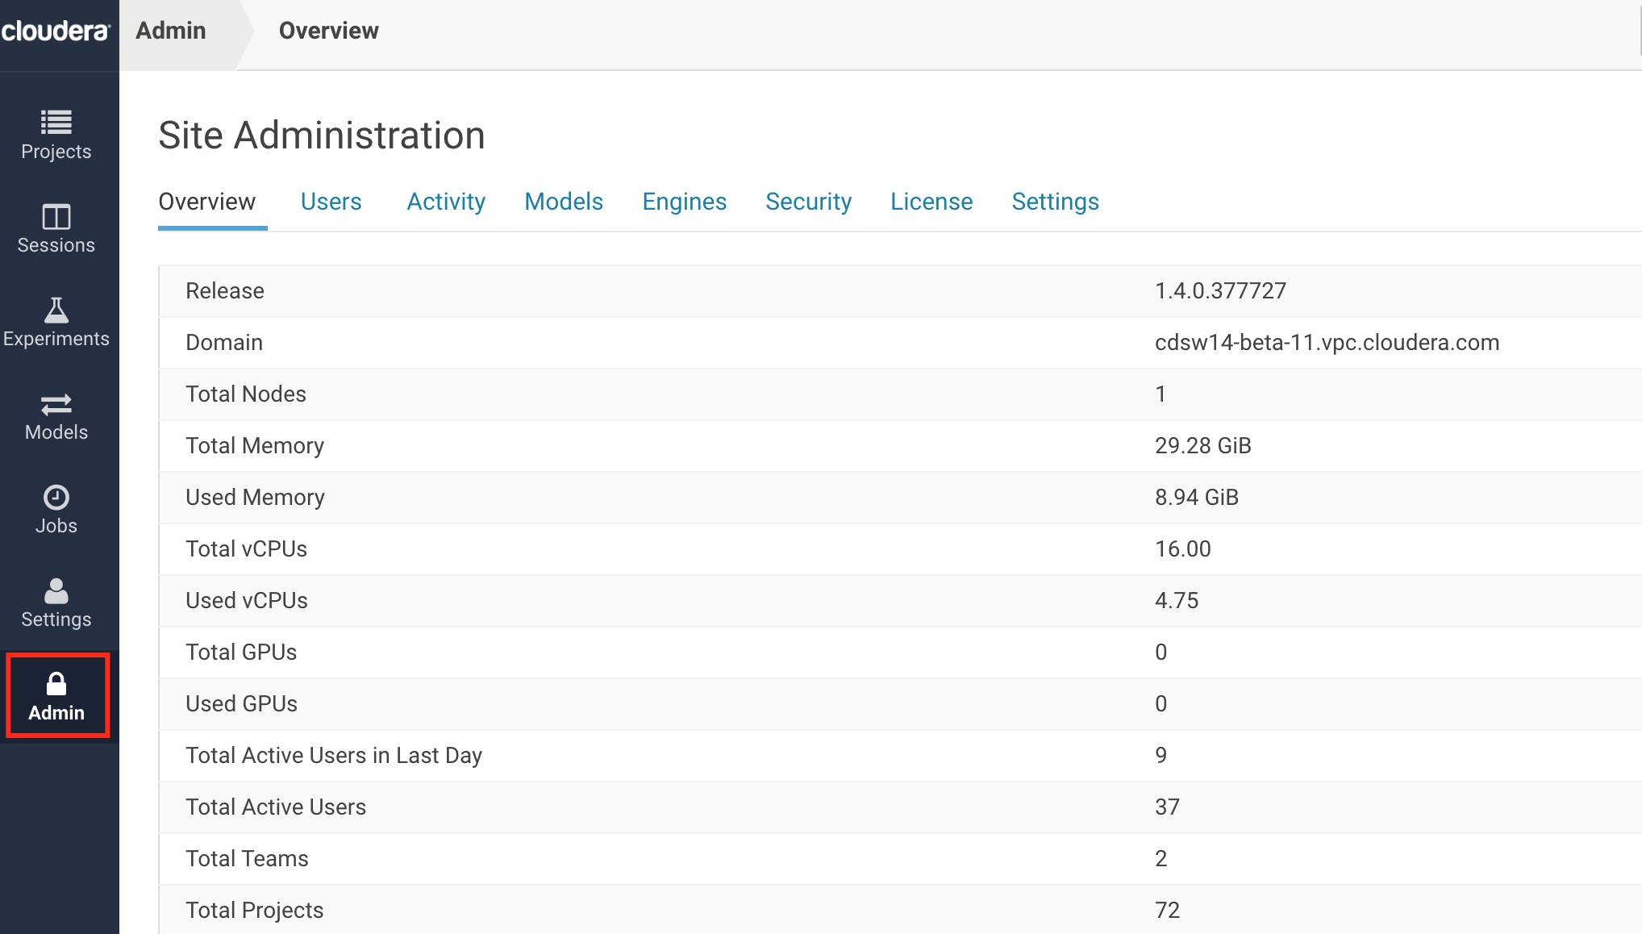

The Users tab gives you some stats on how users are using the system and allows you to do user administrative tasks as well, such as disabling users.

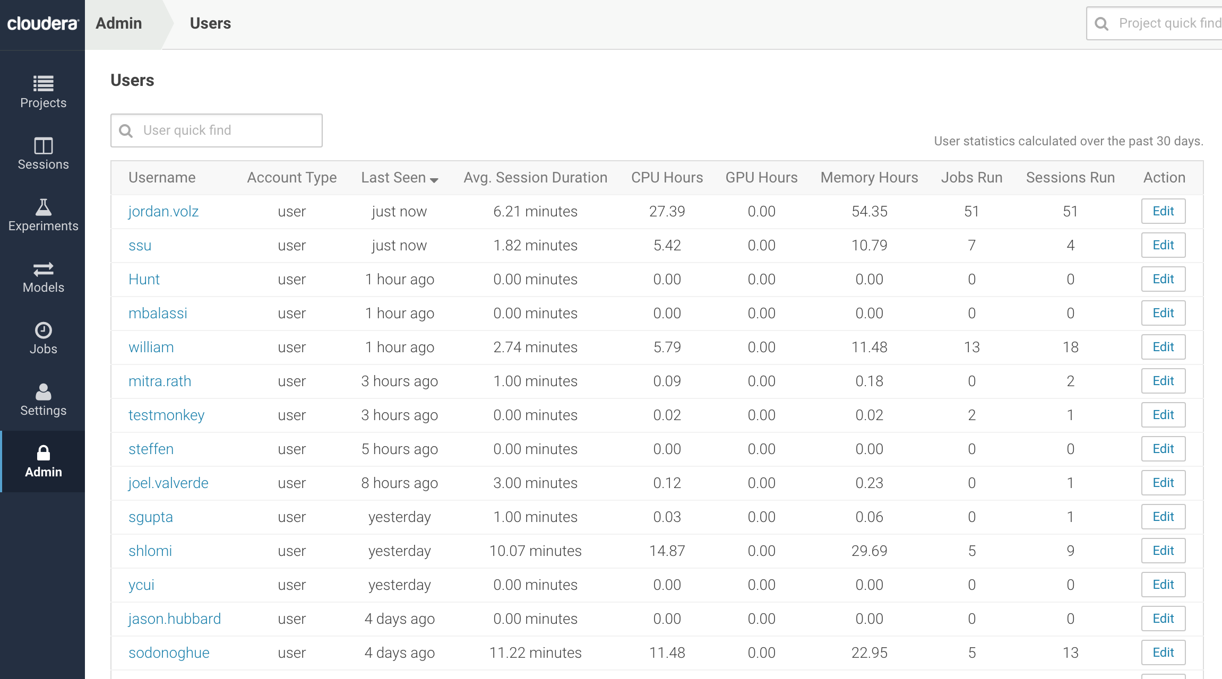

The Activity tab shows a history of all the running containers in the system (interactive sessions, jobs, and experiments). You can graph the usage of system resources over a time frame as well. This allows administrators to easily see if they are reach capacity at peak hours.

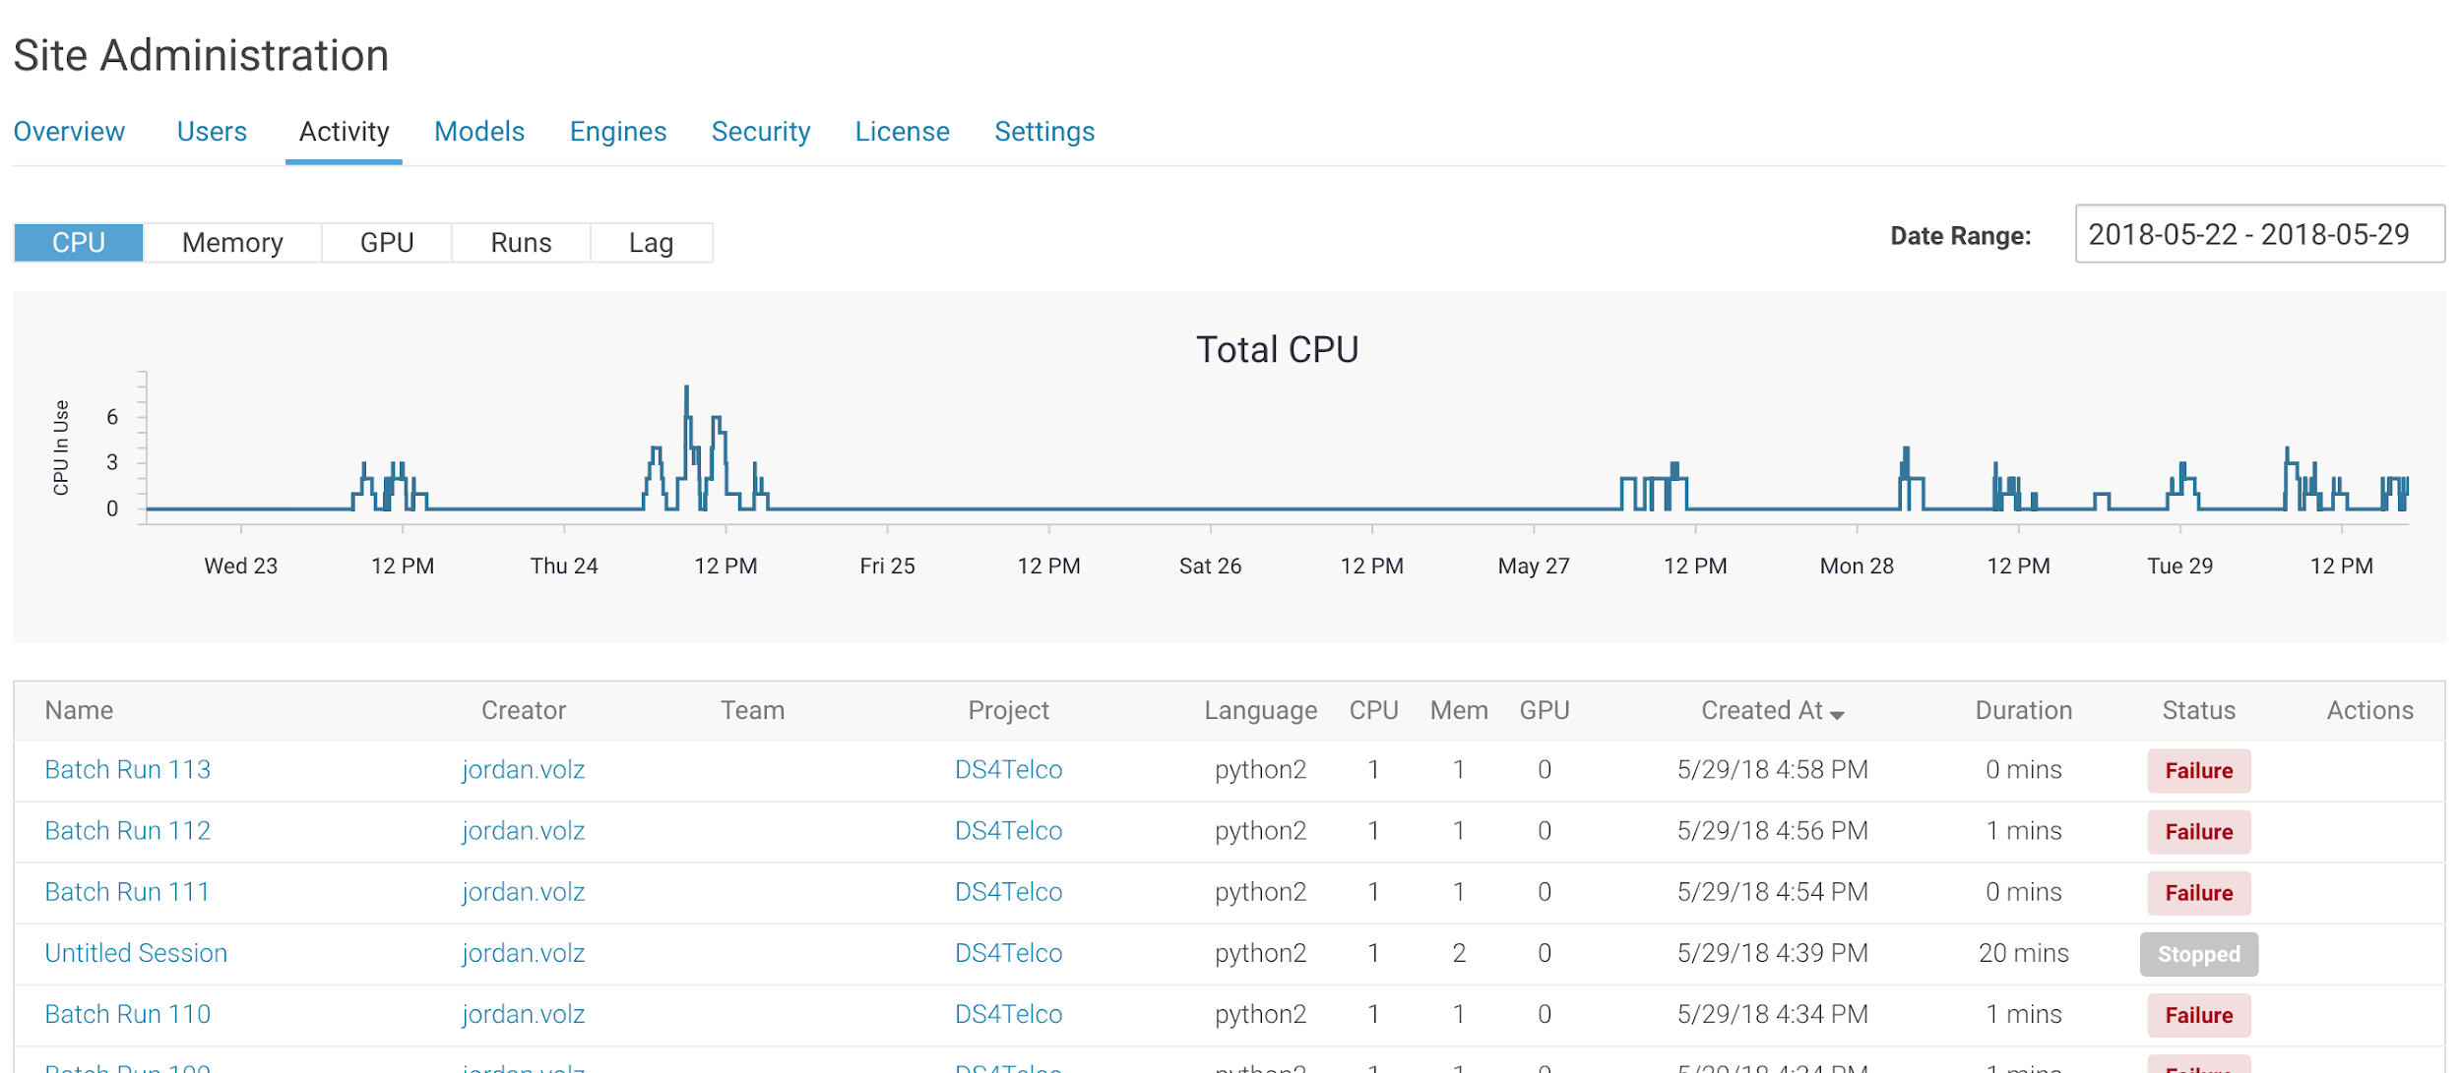

The *Models* tab shows all models that are running in the system and the amount of resources they are taking up.

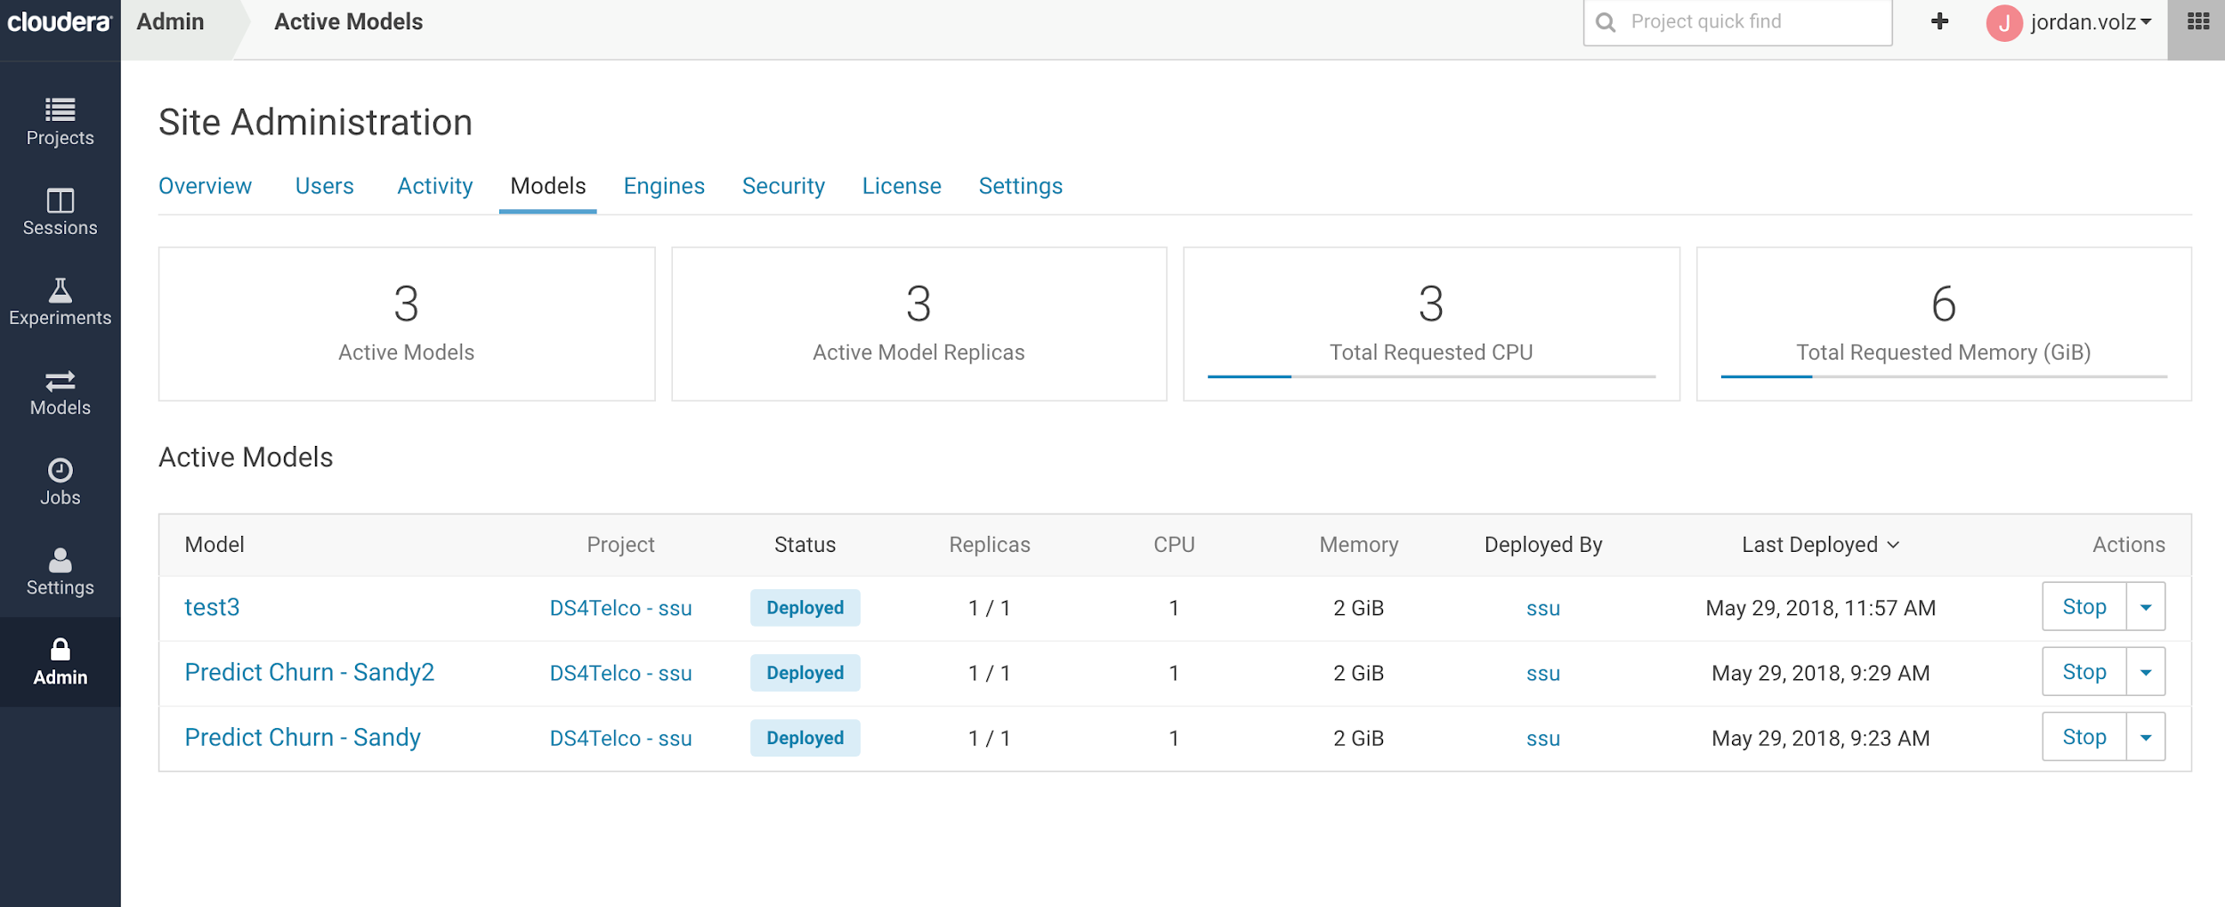

The *Engines* tab allows administrators to define the engine sizes available to users. They’ll also be able to whitelist extended custom engines available (like we saw in our ta-lib example), as well as defining common environment variables or mount points that should be available in all projects.

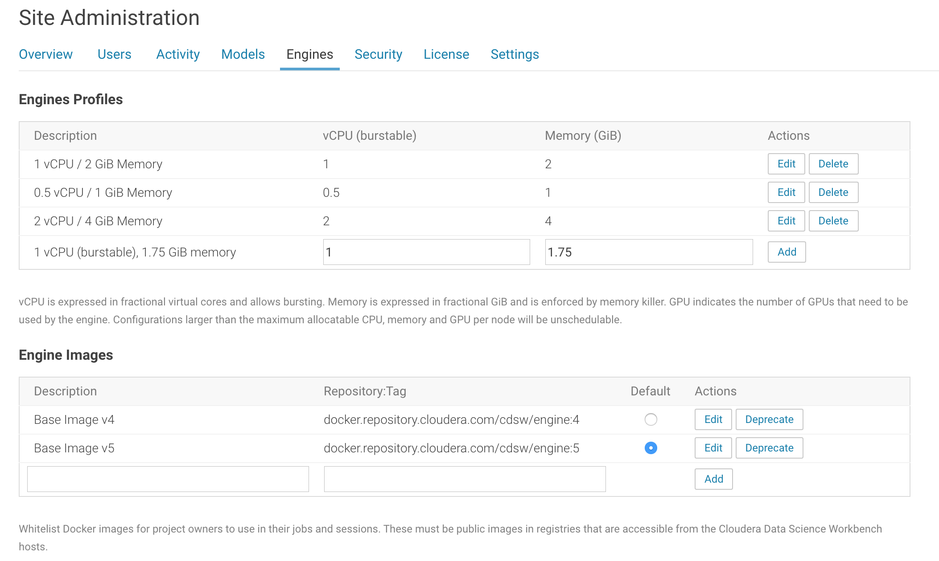

The *Security* tab is where admins can configure LDAP/AD/SSO connections for users, and the *License* tab is where admins upload your CDSW license.

Lastly, in *Settings*, administrators can define custom templates to be made available to users, as well as configuring an SMTP server to use for email.

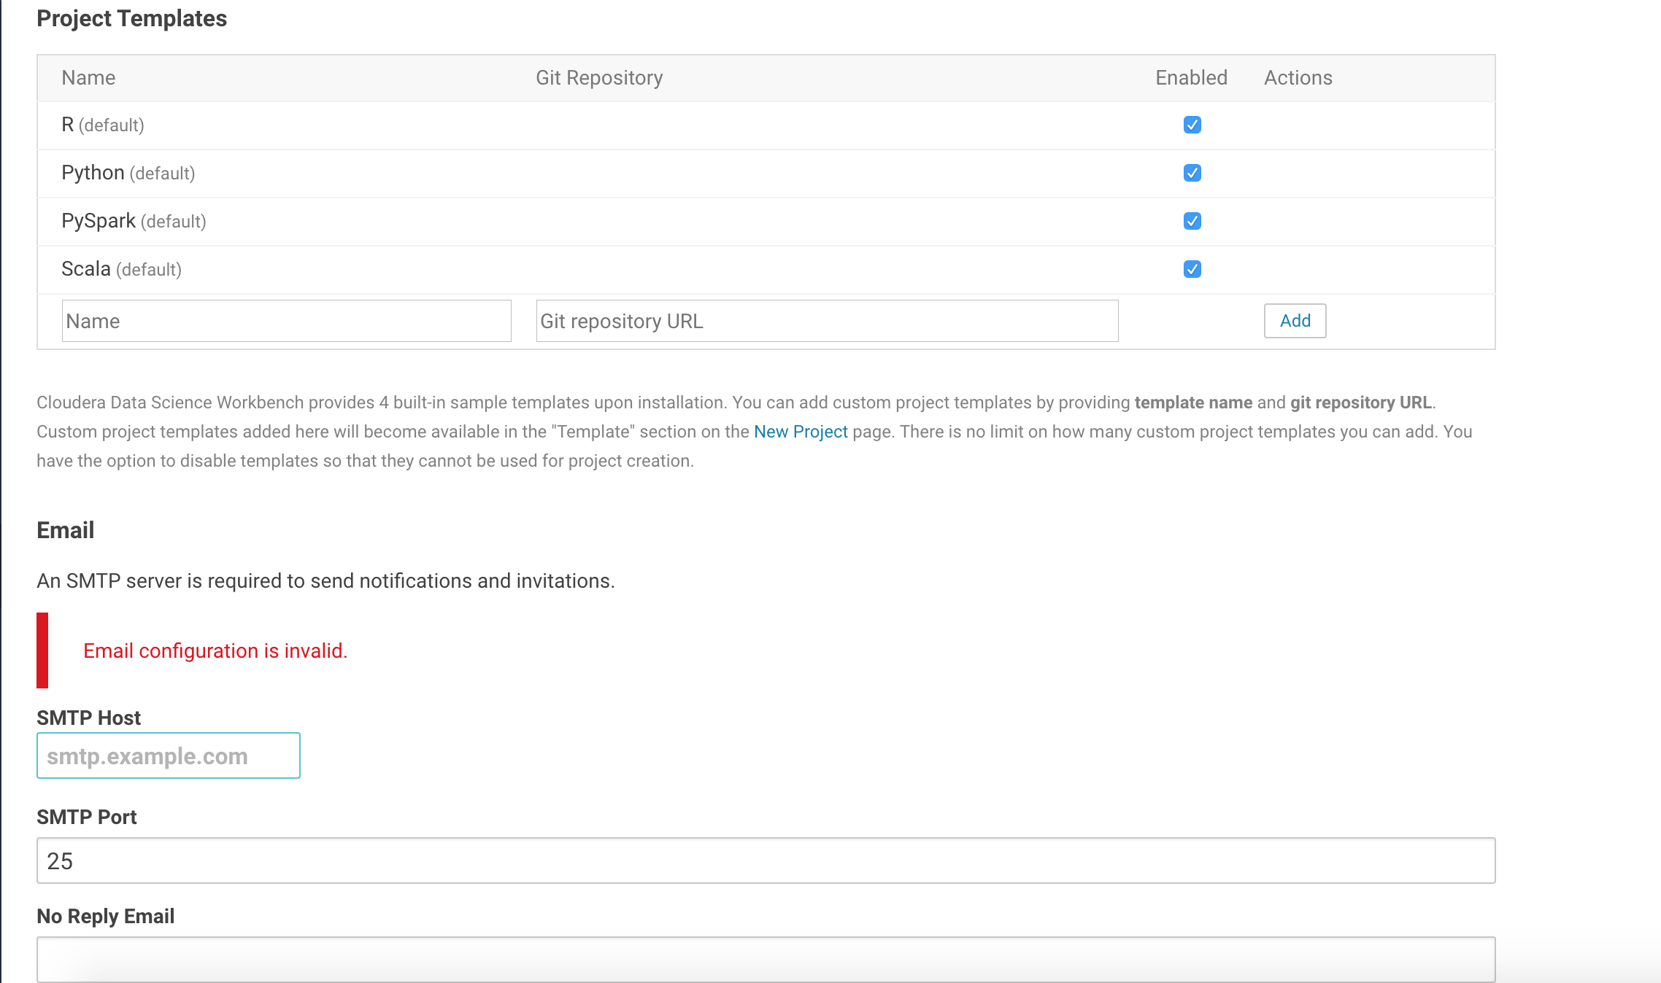

## Appendix C: Web UIs/Shiny Apps

Work in Progress.

## Appendix D: Working with Data in Object Stores

Work in Progress.